GRAPHICAL COVER PAGE

Assessment Report:

Restrictions on Fish Consumption

Beneficial Use Impairment (BUI #1)

for the Niagara River (Canadian) Area of Concern

Month Year | Report Submitted to technical experts and RAP Council for review
Month Year | Recommendation to re-designate the BUI endorsed by Niagara River RAP Council and to proceed with engagement process
Month Year | Engagement process implemented
Month Year | Report updated to incorporate engagement results
Month Year | Report submitted to Canada-Ontario Agreement (COA) Annex Co-leads for review and to re-designate BUI to ‘Not Impaired’
Month Year | Support for BUI re-designation received from COA Annex Co-leads

Draft
Month-Year

Suggested Citation: Niagara River Remedial Action Plan (NRRAP). (2026). J. Nelson, A. Dain, N. Green, T. MacDougall, S. Varty & M. Lee (Eds.), Assessment Report: Restrictions on Fish Consumption Beneficial Use Impairment (BUI #1) for the Niagara River (Canadian) Area of Concern. Thorold, ON.

TABLE OF CONTENTS
ACKNOWLEDGEMENTS ii
TABLE OF CONTENTS iii
EXECUTIVE SUMMARY iii
LIST OF ACRONYMS v
1 INTRODUCTION 1
2 PURPOSE 2
3 BUI DELISTING CRITERIA 2
4 ASSESSMENT OF BUI DELISTING CRITERIA 3
4.1 Criterion 1: Coastal Wetland Habitat 3
4.3 Criterion 2: Shoreline (riparian) habitat vegetation 7
4.4 Criterion 3: Shoreline (Riparian) 5-meter No-mow Vegetated Buffer 3
4.5 Criterion 4: Protection of Unique Habitat 7
5 RECOMMENDATION 7
6 REFERENCES 7
7 ADDITIONAL RESOURCES 9
8 APPENDIX 1: LIST OF COMPLETED ACTIONS 9
9 APPENDIX 2: LIST OUTREACH AND ENGAGEMENT SUMMARY AND RESULTS 11

ACKNOWLEDGEMENTS
The authors gratefully acknowledge the technical working group members and volunteers (past and current) for contributing their expertise, time, and effort toward this assessment process including data collection, data analysis, technical report writing, updating delisting criteria, identifying actions, and preparing and editing this assessment report.
Special thank you to:
- the Niagara River Remedial Action Plan (RAP) Council members for their support and feedback during the development of this document
- Local anglers and Indigenous Communities for completing and/or sharing information about fishing and consumption of fish in the Niagara River
This project was made possible through funding support from the Government of Canada and the Province of Ontario, in partnership with the Niagara Peninsula Conservation Authority. This report was drafted and edited by the Niagara River Remedial Action Plan (RAP) Coordinating Committee.
Technical Working Group members and experts that contributed to this report:

Restrictions on Fish Consumption |  | Niagara River RAP Coordinating Committee
 |  | Melissa Lee, MECP
 |  | Sara Varty, CWA
 |  | Natalie Green, NPCA
 |  | Tom MacDougall, MNR
 |  | Jessi Nelson, NPCA

EXECUTIVE SUMMARY
In 1987, the Niagara River was identified as an Area of Concern (AOC), one of 43 degraded Great Lakes locations requiring effort to restore and improve its water quality and ecosystem health. The Restrictions on Fish Consumption Beneficial Use Impairment (BUI) is one of 14 potential impairments identified in the Canada-U.S. Great Lakes Water Quality Agreement and is typically impaired due to the presence of legacy contaminants, such as polychlorinated biphenyls (PCBs) that persist in the environment and can accumulate in fish tissue.
In Ontario, the fish consumption beneficial use has been listed as ‘Impaired’ for the Niagara River since the completion of the RAP Stage 1 Report (1993) because of contaminants (i.e., PCBs, mercury, mirex) in edible portions of Niagara River fish that prevented unlimited consumption of fish by humans (i.e., 8 or more meals per month). The beneficial use has remained impaired in subsequent RAP Reports (NRRAP 1995, Mackay 2007, NRRAP 2009
Since the 1970s, the Ontario Ministry of Environment, Conservation and Parks (MECP) has monitored specific chemicals in fish flesh through province-wide Fish Contaminant Monitoring Program. The information and data are used to produce the Guide to Eating Ontario Fish (the Guide) and include advisories for both the Upper and Lower section of the Niagara River. In accordance with benchmarks established in the Guide and through scientific research by Gandhi et al. (2015), there are three levels of restrictions on fish consumption. Within the Niagara River AOC, assessment of the Restrictions on Fish Consumption BUI considered the most restrictive consumption limits for target fish species and size classes, with 8+ meals/month being deemed UNRESTRICTED. If any fewer than 8 meals/month could be consumed, then fish consumption was deemed RESTRICTED for that fish or size class.
Since the 1970s, banning of contaminants, like mirex and PCBs, has led to significant decreases in the presence of legacy contaminants with continued evidence they are decreasing over time (Hill, 2022) according to Upstream and Downstream data collected by ECCC. Presently, there are no restrictions on Niagara River fish for mirex and photomirex (2019, MECP unpublished data). Ongoing monitoring programs, such as the Fish Contaminant Monitoring Program (MECP), Upstream-Downstream Water Quality Monitoring (ECCC) under the Niagara River Toxics Management Plan, and Great Lakes Sediment Monitoring Program (ECCC) continue independent of the Niagara River Remedial Action Plan.
With significant progress being made to reduce legacy contaminants in the Niagara River, an assessment of the delisting criteria, as outlined in the Niagara River (Ontario) Delisting Strategy (Green et al., 2021) was conducted to determine the current status of fish consumption restrictions in the Niagara River AOC, is captured in this report. The report includes the most recent information and expert opinion with recommendations for future actions required to address this BUI. Below is a summary of the results of this assessment:
BUI Delisting Criteria
- consumption advisories for fish of interest in the AOC are unrestricted; OR | ⮽
- consumption advisories for fish of interest are no more restrictive than the advisories for suitable reference sites due to contaminants (PCBs and dioxin-like PCBs) from locally-controllable sources; OR | ⮽
- multiple lines of evidence indicate improving conditions over time and all feasible remedial actions are complete. | ☑

LIST OF ACRONYMS

AOC Area of Concern
BUI Beneficial Use Impairment
CWA Canada Water Agency
ECCC Environment and Climate Change Canada
GLWQA Great Lakes Water Quality Agreement
MECP Ministry of Environment, Conservation and Parks
MNR Ministry of Natural Resources
NPC Niagara Parks Commission
NPCA Niagara Peninsula Conservation Authority
NRRAP Niagara River Remedial Action Plan
NRTMP Niagara River Toxics Management Plan
RAP Remedial Action Plan

INTRODUCTION
The Niagara River Area of Concern (AOC) is one of 43 locations in the Great Lakes Basin identified under the Great Lakes Water Quality Agreement (GLWQA) in 1987, as a hotspot of environmental deterioration. Through the GLWQA, the Niagara River AOC received a localized cleanup plan, called a Remedial Action Plan (RAP), to address the environmental degradation through 14 identified environmental challenges, termed Beneficial Use Impairments (BUIs), that are common to all AOCs in the basin.
The Restrictions on Fish Consumption BUI refers to the ability to consume fish
In the Canadian waters of the Niagara River, most fish consumption advisories are due to PCBs (Bhavsar et al. 2011). Historically, mirex/photomirex was also linked to fish consumption restrictions in the Lower Niagara River and Lake Ontario, with the source mainly being industry on the U.S. side of the Niagara River. Mirex was banned in the 1970s and a recent, long-term study shows a 90% decrease of mirex in Lake Ontario fish from 1975-2010 (Gandhi et al. 2015). As of 2019, there are no consumption restrictions for Niagara River fish due to mirex or photomirex (MECP, unpublished data). Both mirex and photomirex continue to be selectively monitored as part of the large analytical suite of measurements conducted through Ontario’s Fish Contaminant Monitoring Program (S. Bhavsar, pers. comm., 2020). There are also consumption advisories related to mercury, lead, and dioxins/furans but, for the Niagara River AOC, it is important to note that:
- mercury is a global pollutant with its major source coming from atmospheric deposition (Bhavsar et al. 2011) and there are no known local sources (Mackay 2007).
- dioxins/furans are only listed for advisories related to eating Brown Bullhead in the Upper Niagara River and are at levels which are UNRESTRICTED (the advisory allows consumption of 16 and 32 meals per month, depending on the size of the fish); there are no advisories related to dioxins/furans for any other species in the Niagara River;
- Lead is only associated with restrictions on eating one species, Redhorse Sucker, from the Upper Niagara River; with the advisory also linked to mercury and PCBs. The consumption of Redhorse Sucker is unrestricted for fish <45 cm, partially restricted for some sizes, and completely restricted for the sensitive population if the fish is >55 cm.
[add in additional details about Restrictions on Fish Consumption BUI in Niagara River Canadian. Some points of reference could be the NRTMP, Priority contaminants, etc. Look to updated DS]

Each delisting criterion is connected to an assessment tier, which was modified from Bhavsar (2018) for the Niagara River. Based on the outcomes of the tiered evaluation(s), a recommendation is made to either maintain the ‘Impaired’ BUI status or to pursue the re-designation of the BUI to ‘Not Impaired’. Not all the tiers need to be met for BUI removal.
For more details on the Delisting Criteria, see Delisting Strategy (2021) and details regarding the Tiered framework are in Appendix x.

PURPOSE
The purpose of this report is to highlight the completed actions (refer to Appendix 1) and summarize the tiered assessment and delisting criteria for the Restrictions on Fish Consumption BUI for the Canadian side of the Niagara River AOC.

BUI DELISTING CRITERIA
As part of the Niagara River RAP’s 5-year Delisting Strategy (NRRAP 2021), updated BUI delisting criteria were developed with community participation and expert input.
The delisting criteria state that the Restrictions on Fish Consumption BUI will no longer be impaired when:
  - consumption advisories for fish of interest in the AOC are unrestricted; OR
  - consumption advisories for fish of interest are no more restrictive than the advisories for suitable reference sites due to contaminants (PCBs and dioxin-like PCBs) from locally-controllable sources; OR
  - multiple lines of evidence indicate improving conditions over time and all feasible remedial actions are complete.
When relevant remedial actions are complete and scientific evidence through a BUI assessment shows these delisting criteria have been met, the RAP Team prepares a recommendation to redesignate the status of the applicable BUI. More information about the rationale and explanation of terminology used in the BUI delisting criteria is provided in detail in the Niagara River (Ontario) Delisting Strategy (2021).

ASSESSMENT METHODS

Tiered assessment framework
In 2018, a group of scientific experts published a suggested assessment framework that could be used by all Canadian AOCs for the Restrictions on Fish Consumption BUI. The study featured a 4-tired framework that was used to assess the BUI and used Toronto and Region AOC as a case study (Bhavsar et al. 2018). The Niagara River (Ontario) Delisting Strategy (2021) presented an adapted 3-tiered assessment framework and application guide for the updated set of delisting criteria, with minor revisions to the 4-tier model presented in Bhavsar et al. (2018). The three tiers of the Niagara River (CDN) AOC framework compile different lines of evidence to determine if the delisting criteria are met with each tier (Figure 4-1).
Tier 1: Consumption advisories for fish of interest in the AOC are unrestrictive.
The delisting criterion at the first tier uses provincial publicly shared fish consumptions advisories through the Guide to Eating Ontario Fish, to determine whether there are restrictions on fish consumption for all fish of interest at all size classes. Consumption is considered UNRESTRICTED if 8 meals or more per month can be consumed by the general population and 4 meals or more per month for the sensitive population (children under 15 and people who are of childbearing age).
Tier 2: Consumption advisories for fish of interest are no more restrictive than the advisories for suitable reference sites due to contaminants from locally-controllable sources.
The delisting criterion for the second tier similarly uses provincial publicly shared fish consumptions advisories through the Guide to Eating Ontario Fish, to determine if consumption advisories for fish of interest in the AOC are more restrictive in AOC fish when compared to reference sites. Only fish species and size classes that failed Tier 1 are evaluated at Tier 2.
Tier 3: Multiple lines of evidence indicate improving conditions over time and all feasible remedial actions are complete
The delisting criterion for the third and final tier utilizes multiple lines of evidence, potentially including fish contaminant data, sediment contaminant data, and history of restoration actions to determine if priority contaminants from locally controllable sources are driving fish consumption restrictions in the AOC. If no feasible actions remain to address local legacy contamination, this delisting criterion can be said to be met.
The framework is designed such that if all fish of interest in the AOC pass a particular tier, the delisting criterion can be said to be met. Otherwise, analysis moves to the next tier. If all tiers are failed, then the delisting criterion cannot be said to be met. It should be noted that, in the Niagara River AOC, the primary contaminants of concern are polychlorinated biphenyls (PCBs). Thus, analyses of contaminants are limited strictly to the sources and concentrations of PCBs in AOC fish.
Since the previous BUI 1 Assessment Report in (year) (reference), the Guide to Eating Ontario Fish has been updated with new fish contaminant data (which was collected on an annual basis, excluding 2020 due to the Covid-19 pandemic [could use citation - Melissa]) where available, including collections of targeted species (such as walleye and yellow perch) following recommendations from the report. Furthermore, a combination of angler surveys and scientific publications were used to assess the BUI in terms of community desired consumption rates of fish of interest, rather than using MECP definitions of restrictive consumption advice (MECP, 2025). These new data were used to make up-do-date comparisons of fish consumption advisories within the AOC and reference areas in the Lake Erie and Lake Ontario.
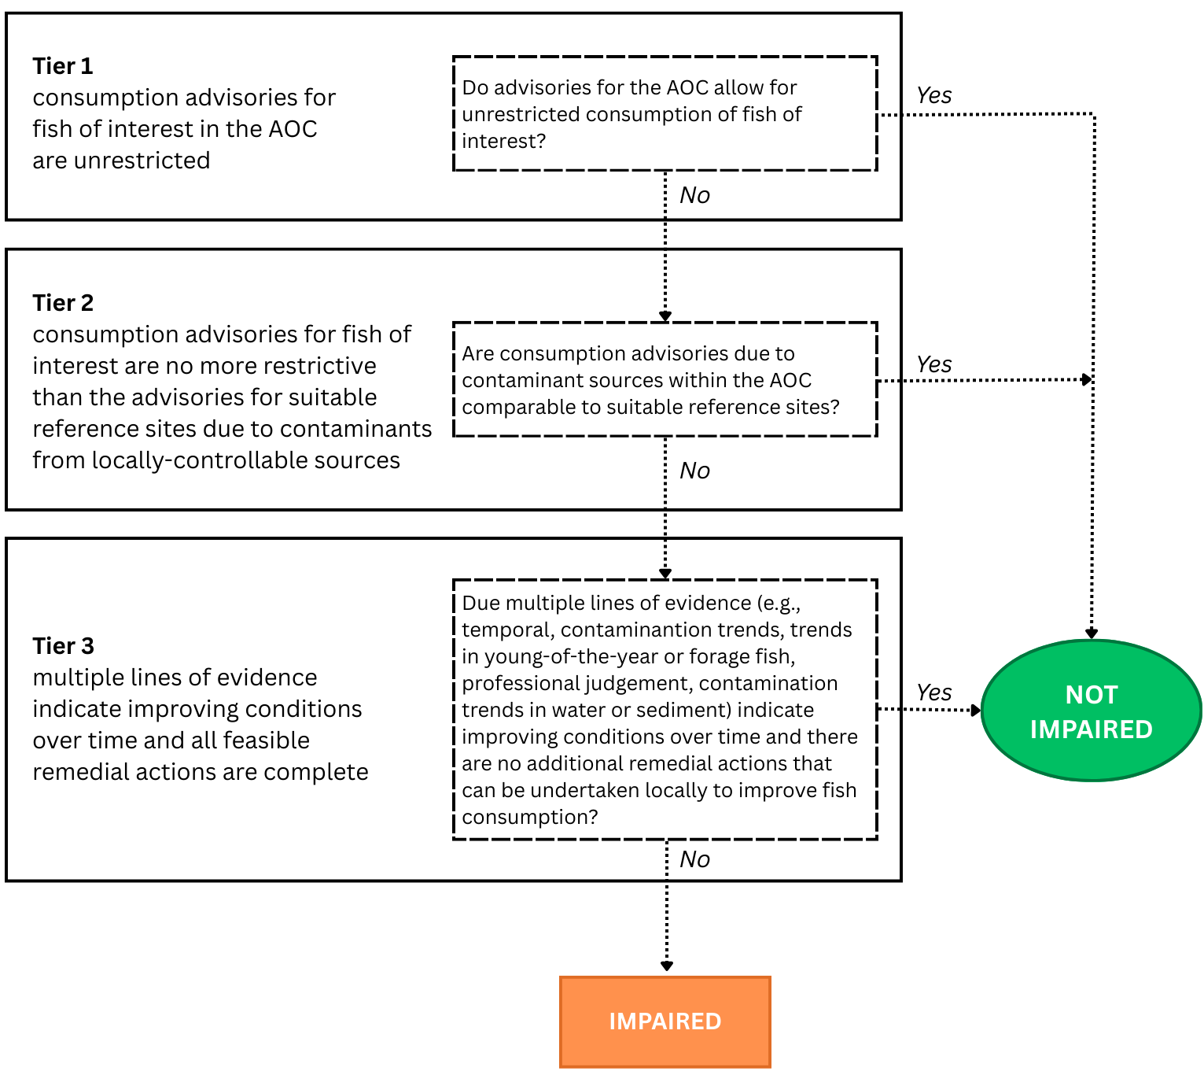

Figure 4-1. Modified 3-Tiered Assessment Framework for the Niagara River (CDN) Area of Concern. The framework identified uses multiple lines of evidence and a tiered approach whereby failure at a lower tier requires assessment at the next level, and successful achievement at a lower tier does not.

FISH SPECIES OF INTEREST

Community fish consumption survey
Preferences and patterns of eating fish can vary by location, type of fish and communities, warranting a reliable fish consumption survey to understand the potential use of the fish resources within the AOC. Surveys (online and in-person) were required to understand which fish people are eating from the Niagara River, and how much they consumed over the previous year. Local Indigenous Communities were consulted and ran their own surveys with community members, maintaining data sovereignty. The data, once aggregated, was used to determine a comprehensive list of all fish of interest within the AOC.
For this BUI assessment, surveys from the following sources were used to determine species of interest and local consumption habits: the Niagara Peninsula Conservation Authority (NPCA; online 2019-2021, n = 157; and in person 2020-2021, n = 237), Missisaugas of the Credit First Nation (MCFN; 2019, n = 44), Six Nations of the Grand River (SN; year, n = 50), and the Metis of Ontario (MNO; year, n = 629). To preserve data sovereignty and privacy of the survey respondents, the summary results were anonymized and pooled for the purposes of this assessment. Respondents were asked about fish consumption habits in the AOC, and in some cases, surrounding areas. Summaries of responses to questions about whether or not the respondents eat fish caught from the AOC, the species they eat, the average consumption frequency of each species, and the average portion size of a fish meal were used. The associated reports for each survey are attached in the Appendix.
Since survey data was used from different sources, it was not always possible to retain exact parity between responses. Survey questions differed in how they asked about where respondents fish and how often they eat each species. For instance, the MNO survey asked respondents about fishing habits in Lake Erie and Lake Ontario separately, and separate questions about a) whether respondents fish in the AOC, and b) whether consumption habits are different in AOCs versus other locations. As the NR AOC was included under “Lake Ontario” for this survey, summary data from this section was used for this assessment. Similarly, the SN survey asked a subset of fishers that consume fish in the NR AOC which species are caught and consumed there, so summary data for these species were used in this assessment. Additionally, consumption frequency questions (eg, “Once a week”, “2-3 times per week”, “3-6 times per month”) differed between surveys, so these were standardized into categories as displayed in Table 1.2. Two of the surveys subsetted some species into family groups that may be easier for respondents to identify (perches, basses, salmonids, pike, catfish, and panfishes), so the consumption frequencies for each of these categories were applied to all species that appear in the Guide to Eating Ontario Fish within them (eg, consumption frequency of “basses” is applied equally across smallmouth and largemouth bass).
Responses from these surveys were used to establish the community’s restrictive consumption threshold for each species using several methods: First, species of interest are defined as those consumed by at least 5% of survey respondents who eat fish. Second, a weighted average for meal frequency was calculated by multiplying the number of respondents by their current monthly consumption rate (converted from survey response options to monthly meal equivalents, see Table 1.2), then dividing by the total number of respondents that eat this species. Third, a weighted average meal size was calculated similarly to frequency, with survey response options converted to monthly meal equivalents as per Table 1.3. In these surveys, average portion size was estimated across species, as there were no species-specific questions for portion size. Finally, the weighted average frequency was multiplied by the weighted average portion size to get an average desired consumption rate, which was rounded up to the next advisory category for the Sensitive population (0, 4, 8, 12, 16, or 32 meals per month).
Table 1.2: Survey response conversion table for desired consumption frequency.
Consumption Rate (Survey) | Conversion
Rarely (<1/month) | 0.5
Once a month | 1
Once a week | 4
2-5 times a week | 16
Daily | 32

Table 1.3: Survey response conversion table for desired portion size
Portion Size (Survey) | Conversion
Less than 4 oz | 0.25
4 oz | 0.50
8 oz | 1.00
Other | 1.50
Since fish consumption restrictions are most impactful to the highest consumers of fish (e.g., subsistence fishers), a separate restrictive consumption threshold was calculated for the top 5% of fish consumers in the AOC, as per survey results. Rather than acquiring average consumption rates, the minimum frequency category consumed by ≥5% of respondents was obtained using cumulative proportions of each category. The highest consumption category capturing at least 5% of respondents was then used as the consumption threshold for the highest consumers. For instance, if 1% of respondents consume a species daily, 3% consume it 2-5 times per week, 10% consume it once a week, and 40% consume it once a month, the restrictive consumption threshold for at least 5% of anglers is once a week or 4 meals a month (1% + 3% + 10% = 14%). This high-consumer information can help inform us of community fish consumption habits in addition to the tiered assessment.
Community survey revealed that a significant proportion of community members may consume some species (walleye, perch, lake whitefish, and lake sturgeon) at rates greater than 8 meals per month. This may indicate that these species are part of a subsistence fishery in the AOC, reflecting a greater need for contaminant monitoring in the interest of protecting human health for these community members. Additionally, community surveys indicated a lower consumption rate of panfishes, basses, salmonids, rainbow smelt, and northern pike, suggesting that even the highest consumers of fish in the AOC are not eating more than 4 meals per month of these species. However, due to the intrinsic limitations of consumption survey data and potential biases people may have for AOC fish, we are using a literature-supported consumption threshold of 8 meals per month (citation), at or above which fish consumption can be considered unrestrictive for the purposes of assessing this BUI.
The following species were identified as species of interest, with the respective restrictive consumption thresholds (see Section 1.3):
Table 2.1: Combined fish consumption survey results for the Niagara River AOC. Summary information from NPCA, MCFN, MNO, and SN were compiled to determine species of interest and consumption rates. Species are listed with the percent of survey respondents that eat them, the average consumption rate weighted by average portion size (in meals/month, rounded up to nearest advisory category), and the average consumption rate weighted by average portion size (in meals/month, rounded up to nearest advisory category). Bolded and asterisked species are consumed by at least 5% of respondents, and are therefore considered species of interest.
Species | Percent Eaten by Respondents | Weighted Average Consumption Rate (meals/month) | Weighted Consumption Threshold (meals/month), Top 5% of Respondents
Walleye* | 70% | 4 | 16
Perch* | 57% | 4 | 16
Panfishes* | 22% | 4 | 4
Basses* | 62% | 4 | 4
Salmonids* | 67% | 4 | 4
Catfish* | 10% | 4 | 16
Carp | 1% | 4 | 4
Pike* | 22% | 4 | 4
Rainbow Smelt* | 11% | 4 | 4
Other* | 15% | 4 | 16
“Other” species included lake sturgeon, lake whitefish, and other unidentified fishes. Lake whitefish will be considered as a species of interest for this assessment. Lake sturgeon does not have official consumption advice, and will therefore not be included in this assessment.

TIER 1 ASSESSMENT

Criterion 1: Consumption Advisories for Fish of Interest
Consumption advisories for fish of interest in the AOC are unrestricted.
The first step of the tiered framework provides a coarse screening of whether fish consumption advisories in the AOC are restrictive in relation to locally desired consumption rates. Given that virtually all fishing zones in Ontario have some fish consumption restrictions in place, there is a need to define a benchmark for the degree of restrictiveness that is considered non-restrictive relative to the normal consumption patterns of fish in a given waterbody by the local community. Advisory values, expressed as the number of meals per month recommended for the general and sensitive population groups, were compiled from the Guide to Eating Ontario Fish, published by the Ontario Ministry of the Environment, Conservation and Parks (MECP; see Section 2.4.0.1). These advisories are based on contaminant concentrations measured in fish flesh and translated into species- and size-specific consumption categories using contaminant thresholds (Table 2.1).

Table 2.1: MECP fish consumption advisory contaminant benchmarks (adapted from Bhavsar 2016). Contaminant concentration values correspond to advised maximum monthly fish meals. Mercury consumption advisories are issued separately for the general population and sensitive population (children under 15 years old and anyone who is pregnant or may become pregnant).
 | Hg (µg/g) |  | PCB (ng/g) | Dioxin/Furan/  dlPCB TEQ (pg/g) | Mirex (ng/g) | Photomirex (ng/g) | Toxaphene (ng/g)
Meals/  month | Sensitive | General
0 | >0.5 | >1.8 | >844 | >21.6 | >657 | >122 | >1877
1 |  |  | 422-844 | 10.8-21.6 | 329-657 | 61-122 | 939-1877
2 |  |  | 211-422 | 5.4-10.8 | 164-329 | 31-61 | 469-939
4 | 0.25-0.5 | 0.6-1.2 | 105-211 | 2.7-5.4 | 82-164 | 15-31 | 235-469
8 | 0.16-0.25 | 0.4-0.6 | 70-105 | 1.8-2.7 | 55-82 | 10-15 | 156-235
12 | 0.12-0.16 | 0.3-0.4 | 53-70 | 1.3-1.8 | 41-55 | 8-10 | 111-156
16 | 0.06-0.12 | 0.15-0.3 | 26-53 | 0.7-1.3 | 21-41 | 4-8 | 59-117
32 | <0.06 | <0.15 | <26 | <0.7 | <21 | <4 | <59

Advisory values for each fish of interest in the AOC were then compared against a benchmark representing acceptable levels of consumption (8 meals per month). Any advisory below this benchmark was considered restrictive, while those at or above the benchmark were considered non-restrictive. This step provides a baseline indication of potential impairment and allows the RAP team to identify species or size classes where consumption guidance is most restrictive, independent of regional comparisons. Additionally, Tier 1 excludes unrestricted fish from further analysis, since these species meet the delisting criteria at its most basic level. If all species pass Tier 1, delisting criterion 1 can be said to be met. Tier 1 uses a strict passing benchmark, where any number of restrictive size categories in either population type (General or Sensitive) will cause a species to fail and move to Tier 2. Tables 2.1 and 2.3 summarize the MECP advisory values for fish of interest in the Niagara River AOC for both General and Sensitive populations, compared to a restrictive consumption threshold of 8 meals/month (citation for where this comes from). Tier 1 analyses are conducted separately for the Upper and Lower reaches of the Niagara River respectively.

Upper Reach

Table 2.2: Results of Tier 1 assessment for the Niagara River (Upper reach) fishing zone. The consumption advisory for each species is compared to its desired consumption rate, as determined by community survey. Numbers in cells indicate advisory levels for a species, size class, and population type (General/Sensitive) in the AOC. Red cells indicate an advisory below the "Restrictive" meals/month threshold of 8 meals per month and green cells indicate advisory levels equal to or above this threshold. The contaminants driving the advisories are displayed below each cell.
Species | Population | 15-20 cm | 20-25 cm | 25-30 cm | 30-35 cm | 35-40 cm | 40-45 cm | 45-50 cm | 50-55 cm | 55-60 cm | 60-65 cm | 65-70 cm | 70-75 cm | >75 cm
Brown Trout | General |  |  |  | 4
 | Adv cause |  |  |  | 3
 | Sensitive |  |  |  | 4
 | Adv cause |  |  |  | 3
Freshwater Drum | General |  | 12 | 12 | 12 | 12 | 12 | 8 | 4 | 4 | 4 | 4
 | Adv cause |  | 3 | 3 | 3 | 3 | 3 | 3 | 2, 3 | 3 | 3 | 3
 | Sensitive |  | 12 | 12 | 12 | 12 | 12 | 8 | 4 | 4 | 4 | 4
 | Adv cause |  | 3 | 2 | 3 | 3 | 2 | 2 | 3 | 2 | 2 | 2
Largemouth Bass | General | 32 | 32 | 32 | 32 | 16 | 12 | 4
 | Adv cause |  |  |  |  | 2 | 2 | 2
 | Sensitive | 16 | 16 | 12 | 12 | 8 | 4 | 0
 | Adv cause | 2 | 2 | 2 | 2 | 2 | 2 | 2
Northern Pike | General |  |  | 32 | 32 | 32 | 32 | 32 | 32 | 32 | 32 | 32 | 16 | 16
 | Adv cause |  |  |  |  |  |  |  |  |  |  |  | 2 | 2
 | Sensitive |  |  | 16 | 16 | 16 | 16 | 12 | 12 | 12 | 12 | 12 | 12 | 8
 | Adv cause |  |  | 2 | 2 | 2 | 2 | 2 | 2 | 2 | 2 | 2 | 2 | 2
Rainbow Smelt | General | 12
 | Adv cause | 3
 | Sensitive | 12
 | Adv cause | 3
Rainbow Trout | General |  |  | 8 | 8 | 8 | 8 | 4 | 2 | 2 | 1 | 1
 | Adv cause |  |  | 3 | 3 | 3 | 3 | 3 | 3 | 3 | 3 | 3, 1
 | Sensitive |  |  | 8 | 8 | 8 | 8 | 4 | 0 | 0 | 0 | 0
 | Adv cause |  |  | 3 | 3 | 3 | 3 | 3 | 3 | 3 | 3 | 3
Rock Bass | General | 32 | 16 | 8
 | Adv cause |  | 2 | 2
 | Sensitive | 16 | 8 | 0
 | Adv cause | 2 | 2 | 2
Smallmouth Bass | General | 16 | 16 | 16 | 16 | 16 | 12 | 4
 | Adv cause | 2, 3 | 2, 3 | 2, 3 | 2, 3 | 2, 3 | 3 | 3
 | Sensitive | 16 | 16 | 12 | 8 | 8 | 4 | 4
 | Adv cause | 2 | 2 | 2 | 2 | 2 | 2 | 2
Walleye | General |  | 16 | 16 | 16 | 12 | 12 | 8 | 8 | 4 | 4 | 4
 | Adv cause |  | 3 | 3 | 3 | 3 | 3 | 3 | 3 | 3 | 3 | 2, 3
 | Sensitive |  | 16 | 16 | 12 | 8 | 8 | 4 | 4 | 4 | 0 | 0
 | Adv cause |  | 2, 3 | 2, 3 | 2 | 2 | 2 | 2 | 2 | 2 | 2 | 2
White Perch | General | 4 | 4 | 4
 | Adv cause | 3 | 3 | 3
 | Sensitive | 4 | 4 | 4
 | Adv cause | 3 | 3 | 2, 3
Yellow Perch | General | 32 | 32 | 16 | 16
 | Adv cause |  |  | 2, 3 | 2, 3
 | Sensitive | 16 | 16 | 16 | 8
 | Adv cause | 2 | 2 | 2 | 2
Advisory causes: 1 = Dioxins/Furans; 2 = Mercury; 3 = PCB; 4 = PFAS

Lower reach

Table 2.4: Results of Tier 1 assessment for Niagara River (Lower reach). The consumption advisory for each species is compared to its desired consumption rate, as determined by community survey. Numbers in cells indicate advisory levels for a species, size class, and population type (General/Sensitive) in the AOC. Red cells indicate an advisory below the "Restrictive" meals/month threshold (indicated by community survey), and green cells indicate advisory levels equal to or above this threshold. The contaminants driving the advisories are displayed below each cell.
Species | Population | 15-20 cm | 20-25 cm | 25-30 cm | 30-35 cm | 35-40 cm | 40-45 cm | 45-50 cm | 50-55 cm | 55-60 cm | 60-65 cm | 65-70 cm | 70-75 cm | >75 cm
Brown Trout | General |  |  |  |  |  | 4 | 2 | 2 | 1 | 1 | 1
 | Adv cause |  |  |  |  |  | 3, 4 | 3 | 3 | 3 | 3 | 3
 | Sensitive |  |  |  |  |  | 4 | 0 | 0 | 0 | 0 | 0
 | Adv cause |  |  |  |  |  | 3, 4 | 3 | 3 | 3 | 3 | 3
Chinook Salmon | General |  |  |  |  |  |  | 1 | 1 | 1 | 1 | 1 | 1 | 1
 | Adv cause |  |  |  |  |  |  | 3 | 3 | 3 | 3 | 3 | 3 | 3, 1
 | Sensitive |  |  |  |  |  |  | 0 | 0 | 0 | 0 | 0 | 0 | 0
 | Adv cause |  |  |  |  |  |  | 3 | 3 | 3 | 3 | 3 | 3 | 3, 1
Coho Salmon | General |  |  |  |  |  | 4 | 4 | 4 | 4 | 4 | 2 | 2 | 0
 | Adv cause |  |  |  |  |  | 3 | 3 | 3 | 3 | 3 | 3 | 3 | 3
 | Sensitive |  |  |  |  |  | 4 | 4 | 4 | 4 | 4 | 0 | 0 | 0
 | Adv cause |  |  |  |  |  | 3 | 3 | 3 | 3 | 3 | 3 | 3 | 2, 3
Freshwater Drum | General | 4 | 4 | 4 | 4 | 4 | 4 | 2 | 2 | 2
 | Adv cause | 3 | 3 | 3 | 3 | 3 | 3 | 3 | 3 | 3
 | Sensitive | 4 | 4 | 4 | 4 | 4 | 4 | 0 | 0 | 0
 | Adv cause | 3 | 3 | 3 | 3 | 3 | 2, 3 | 2, 3 | 2, 3 | 3
Lake Trout | General |  |  |  |  |  |  |  | 2 | 2 | 2 | 0 | 0 | 0
 | Adv cause |  |  |  |  |  |  |  | 3 | 3 | 3 | 3 | 3 | 3
 | Sensitive |  |  |  |  |  |  |  | 0 | 0 | 0 | 0 | 0 | 0
 | Adv cause |  |  |  |  |  |  |  | 3 | 3 | 3 | 3 | 3 | 3
Largemouth Bass | General |  | 32 | 16 | 8 | 4 | 4
 | Adv cause |  |  | 2, 3 | 3 | 3 | 2
 | Sensitive |  | 12 | 8 | 4 | 4 | 0
 | Adv cause |  | 2 | 2 | 2 | 2 | 2
Northern Pike | General |  |  |  |  |  |  | 32 | 16 | 16 | 16 | 16 | 16 | 8
 | Adv cause |  |  |  |  |  |  |  | 3 | 2, 3 | 2, 3 | 2, 3 | 2, 3 | 2, 3
 | Sensitive |  |  |  |  |  |  | 16 | 12 | 8 | 8 | 8 | 4 | 4
 | Adv cause |  |  |  |  |  |  | 2, 3 | 2 | 2 | 2 | 2 | 2 | 2
Rainbow Smelt | General | 4
 | Adv cause | 4
 | Sensitive | 4
 | Adv cause | 4
Rainbow Trout | General |  |  | 4 | 4 | 4 | 4 | 4 | 4 | 4 | 4 | 4 | 4 | 1
 | Adv cause |  |  | 3 | 3 | 3 | 3 | 3 | 3 | 3 | 3 | 3 | 3 | 3
 | Sensitive |  |  | 4 | 4 | 4 | 4 | 4 | 4 | 4 | 4 | 4 | 4 | 0
 | Adv cause |  |  | 3 | 3 | 3 | 3 | 3 | 3 | 3 | 3 | 3 | 3 | 2, 3
Rock Bass | General | 8 | 8 | 8
 | Adv cause | 3 | 3 | 3
 | Sensitive | 8 | 8 | 4
 | Adv cause | 3 | 2 | 2
Smallmouth Bass | General |  | 4 | 2 | 2 | 2 | 2 | 2
 | Adv cause |  | 3 | 3 | 3 | 3 | 3 | 3
 | Sensitive |  | 4 | 0 | 0 | 0 | 0 | 0
 | Adv cause |  | 3 | 3 | 3 | 3 | 3 | 2, 3
Walleye | General |  |  | 16 | 16 | 16 | 12 | 8 | 8 | 8 | 4 | 4 | 4
 | Adv cause |  |  | 3 | 3 | 2, 3 | 3 | 3 | 3 | 2, 3 | 3 | 2 | 2
 | Sensitive |  |  | 16 | 12 | 8 | 8 | 4 | 4 | 4 | 0 | 0 | 0
 | Adv cause |  |  | 2 | 2, 3 | 2 | 2, 3 | 2 | 2, 3 | 2, 3 | 2 | 2 | 2
White Perch | General | 0 | 0 | 0 | 0
 | Adv cause | 3 | 3 | 3 | 3
 | Sensitive | 0 | 0 | 0 | 0
 | Adv cause | 3 | 3 | 2 | 2
Yellow Perch | General | 32 | 16 | 16 | 4
 | Adv cause |  | 3 | 3 | 2
 | Sensitive | 16 | 12 | 12 | 0
 | Adv cause | 2 | 2 | 2 | 2
Advisory causes: 1 = Dioxins/Furans; 2 = Mercury; 3 = PCB; 4 = PFAS

Table 2.5: Results by species of Tier 1 assessment for Niagara River. The consumption advisory for each species is compared to an unrestrictive consumption benchmark of 8 meals per month. Species for which the consumption advisory is equal to or above the benchmark at all size classes pass Tier 1 and are excluded from further analysis; otherwise, the species fails and moves forward to Tier 2.
Species | Tier 1 Upper Reach | Tier 1 Lower Reach
Brown Trout | ❌ | ❌
Chinook Salmon | - | ❌
Coho Salmon | - | ❌
Freshwater Drum | ❌ | ❌
Lake Trout | - | ❌
Largemouth Bass | ❌ | ❌
Northern Pike | - | ❌
Rainbow Smelt | - | ❌
Rainbow Trout | ❌ | ❌
Rock Bass | ❌ | ❌
Smallmouth Bass | ❌ | ❌
Walleye | ❌ | ❌
White Perch | ❌ | ❌
Yellow Perch | ✔️ | ❌

In the Upper Niagara River, yellow perch and walleye passed Tier 1 assessment. The remainder of species of interest failed and move forward to Tier 2 assessment. In the Lower Niagara River, all species of interest failed Tier 1, and analyses of these species move forward to Tier 2 assessment. Thus, delisting criterion 1 cannot be said to be met.

TIER 2 ASSESSMENT

Criterion 2: Consumption Advisories for Fish of Interest
Consumption advisories for fish of interest are no more restrictive than the advisories for suitable reference sites due to contaminants (PCBs and dioxin-like PCBs) from locally-controlled sources.
Tier 2 assesses whether the fish consumption advisories for fish of interest in the AOC are comparable to those at suitable reference sites. If all the restrictive advisories for a given species in the AOC are less restrictive or equivalent to those in reference sites, the species passes Tier 2. Otherwise, the assessment of failing species moves to Tier 3. Species and size classes that passed Tier 1 assessment were excluded from Tier 2 analysis.
Tier 2 assessment compares the intensity of fish consumption advisories in the AOC to suitable reference sites. Reference sites for Tier 2 assessment should reflect background levels of intensity of advisories, i.e., they should represent geographically similar locations that are not AOCs. Furthermore, they need to have fish consumption advisories issued for the selected species of interest as well as overlapping size ranges of each species of that in the AOC. For the Niagara River AOC, reference sites were non-AOC fishing zones in the Lake Erie and Lake Ontario for which advisories for species located in the AOC were available. The following reference sites were used for the Tier 2 analysis of the NR AOC:
- Wheatley Harbour (Lake Erie)
- Rondeau Bay (Lake Erie)
- Lake Erie
- Jordan Harbour (Lake Ontario)
- Lake Ontario (Western Basin)
- Lake Ontario (Eastern Basin)
- Frenchman Bay (Lake Ontario)
- McLaughlin Bay (Lake Ontario)
- Whitby Harbour (Lake Ontario)
- East Lake
- West Lake
- Cataraqui Bay (Lake Ontario)
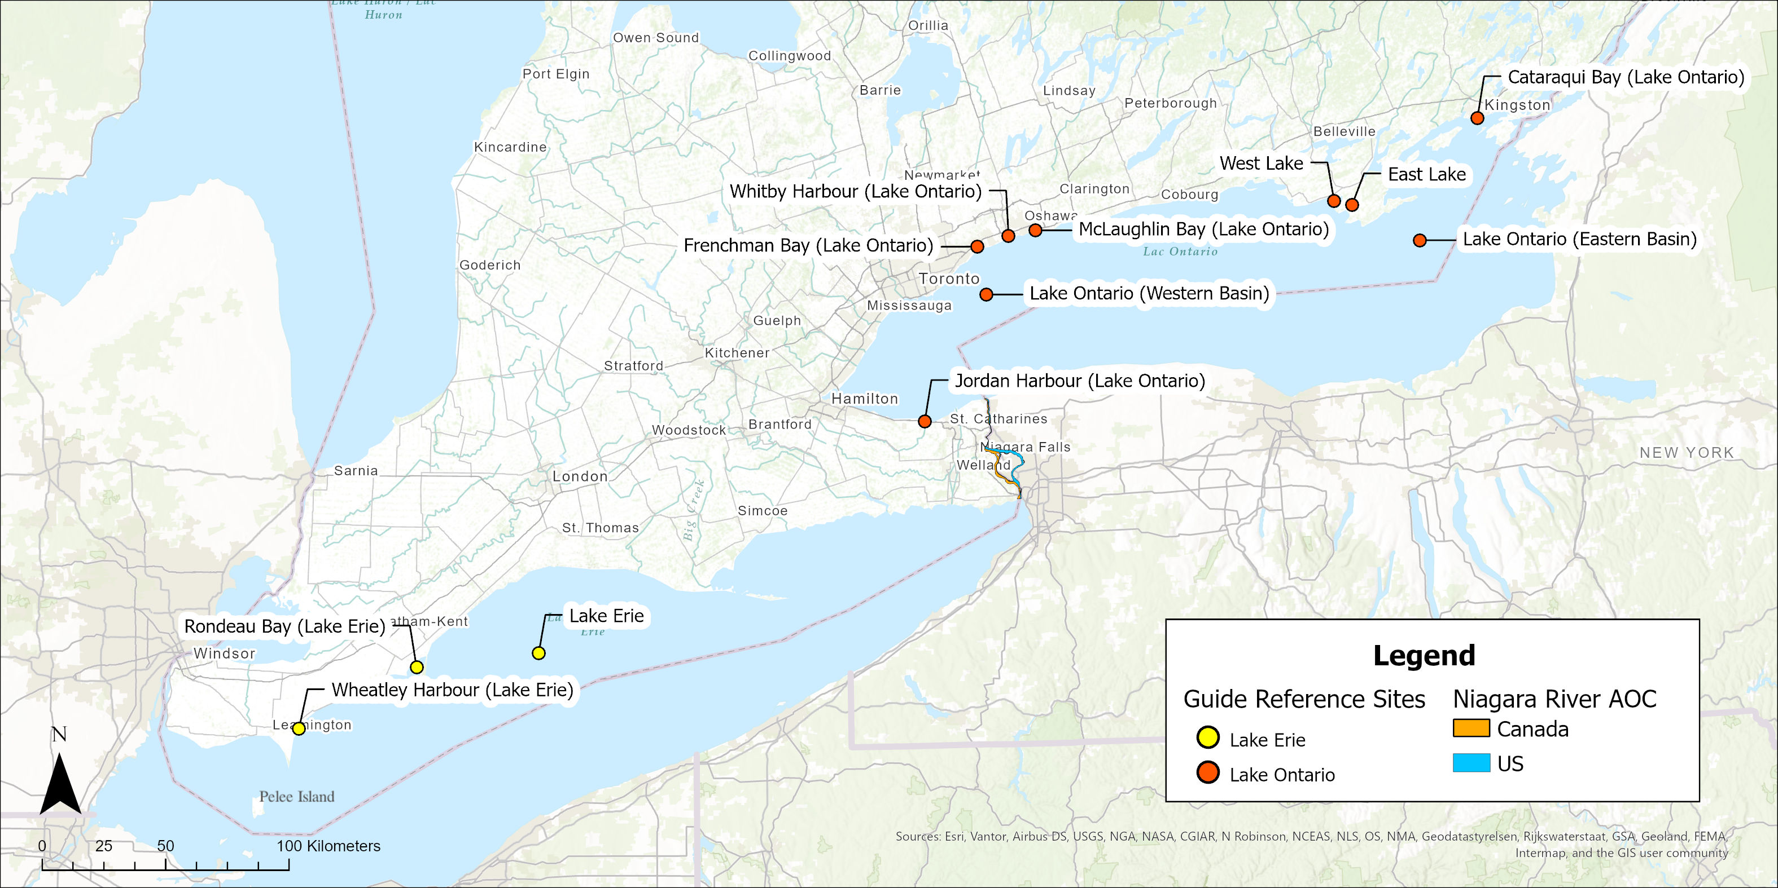
Figure 6.1: Reference sites used in the Tier 2 assessment of the Fish and Wildlife Consumption BUI in the Niagara River AOC.
To compare the intensity of advisories, we compared the advisory value for each species and size class, each for the General and Sensitive populations, for available species of interest in the AOC (below the Tier 1 benchmark) to the median of reference advisories for which advisories were issued for the same species. Because meal/month consumption advisories are issued in discrete categories (see Section 2.4.0.1), reference median values were rounded down to the next advisory value when there were an even number of reference sites (and the true median would therefore fall between advisory categories). For example, a median advisory value of 10 meals/month would be rounded down to 8 meals/month. While this does not change the outcome of the analysis, it is a clearer representation of official consumption advice. AOC advisory values below the desired consumption benchmark (e.g., 8 meals/month) are compared to their respective reference medians, and those size categories equal to or above the reference median pass Tier 2 assessment, while those below the reference median fail Tier 2. Similarly to Tier 1, Tier 2 uses a strict benchmark, where any number of size categories for either population type will cause a species to fail and move to Tier 3.

Upper reach

Table 2.6: Results of Tier 2 assessment for Niagara River (Upper reach). Numbers in cells indicate advisory levels for a species, size class, and population type (General/Sensitive) in the AOC, alongside the median advisory level of suitable reference sites. n values indicate the number of reference sites with advisories for this species, size class, and population type. Red cells indicate an advisory in the AOC lower than the median of reference sites, and solid green cells indicate advisories levels equal to or above the reference median. Transparent green cells indicate size classes that passed Tier 1 (i.e., the advisory value meets the desired consumption rate). Grey cells are advisories in the AOC with an insufficient number (fewer than 3) of suitable reference sites. The drop-down menus display the advisory levels in each reference site for that species and population type.
Species | Population | Site | 15-20 cm | 20-25 cm | 25-30 cm | 30-35 cm | 35-40 cm | 40-45 cm | 45-50 cm | 50-55 cm | 55-60 cm | 60-65 cm | 65-70 cm
Brown Trout | General | AOC |  |  |  | 4
 |  | Ref. Median |  |  |  | 4
 |  | n |  |  |  | 2
 | Sensitive | AOC |  |  |  | 4
 |  | Ref. Median |  |  |  | 4
 |  | n |  |  |  | 2
Freshwater Drum | General | AOC |  |  |  |  |  |  |  | 4 | 4 | 4 | 4
 |  | Ref. Median |  |  |  |  |  |  |  | 4 | 4 | 4 | 8
 |  | n |  |  |  |  |  |  |  | 7 | 6 | 5 | 3
 | Sensitive | AOC |  |  |  |  |  |  |  | 4 | 4 | 4 | 4
 |  | Ref. Median |  |  |  |  |  |  |  | 4 | 4 | 4 | 4
 |  | n |  |  |  |  |  |  |  | 7 | 6 | 5 | 3
Largemouth Bass | General | AOC |  |  |  |  |  |  | 4
 |  | Ref. Median |  |  |  |  |  |  | 4
 |  | n |  |  |  |  |  |  | 4
 | Sensitive | AOC |  |  |  |  |  | 4 | 0
 |  | Ref. Median |  |  |  |  |  | 4 | 0
 |  | n |  |  |  |  |  | 7 | 4
Rainbow Trout | General | AOC |  |  |  |  |  |  |  | 2 | 2 | 1 | 1
 |  | Ref. Median |  |  |  |  |  |  |  | 4 | 4 | 2 | 2
 |  | n |  |  |  |  |  |  |  | 3 | 3 | 3 | 3
 | Sensitive | AOC |  |  |  |  |  |  |  | 0 | 0 | 0 | 0
 |  | Ref. Median |  |  |  |  |  |  |  | 4 | 4 | 0 | 0
 |  | n |  |  |  |  |  |  |  | 3 | 3 | 3 | 3
Rock Bass | General | AOC
 |  | Ref. Median
 |  | n
 | Sensitive | AOC |  |  | 0
 |  | Ref. Median |  |  | 4
 |  | n |  |  | 5
Smallmouth Bass | General | AOC |  |  |  |  |  |  | 4
 |  | Ref. Median |  |  |  |  |  |  | 2
 |  | n |  |  |  |  |  |  | 4
 | Sensitive | AOC |  |  |  |  |  | 4 | 4
 |  | Ref. Median |  |  |  |  |  | 0 | 0
 |  | n |  |  |  |  |  | 6 | 4
Walleye | General | AOC |  |  |  |  |  |  |  |  | 4 | 4 | 4
 |  | Ref. Median |  |  |  |  |  |  |  |  | 8 | 4 | 4
 |  | n |  |  |  |  |  |  |  |  | 6 | 6 | 4
 | Sensitive | AOC |  |  |  |  |  |  | 4 | 4 | 4 | 0 | 0
 |  | Ref. Median |  |  |  |  |  |  | 4 | 4 | 0 | 0 | 0
 |  | n |  |  |  |  |  |  | 6 | 6 | 6 | 6 | 4
White Perch | General | AOC | 4 | 4 | 4
 |  | Ref. Median | 8 | 8 | 4
 |  | n | 6 | 6 | 6
 | Sensitive | AOC | 4 | 4 | 4
 |  | Ref. Median | 8 | 8 | 4
 |  | n | 6 | 6 | 6

Lower reach
Table 2.8: Results of Tier 2 assessment for Niagara River (Lower reach). Numbers in cells indicate advisory levels for a species, size class, and population type (General/Sensitive) in the AOC, alongside the median advisory level of suitable reference sites. n values indicate the number of reference sites with advisories for this species, size class, and population type. Red cells indicate an advisory in the AOC lower than the median of reference sites, and solid green cells indicate advisories levels equal to or above the reference median. Transparent green cells indicate size classes that passed Tier 1 (i.e., the advisory value meets the desired consumption rate). Grey cells are advisories in the AOC with an insufficient number (fewer than 3) of suitable reference sites. The drop-down menus display the advisory levels in each reference site for that species and population type.
Species | Population | Site | 15-20 cm | 20-25 cm | 25-30 cm | 30-35 cm | 35-40 cm | 40-45 cm | 45-50 cm | 50-55 cm | 55-60 cm | 60-65 cm | 65-70 cm | 70-75 cm | >75 cm
Brown Trout | General | AOC |  |  |  |  |  | 4 | 2 | 2 | 1 | 1 | 1
 |  | Ref. Median |  |  |  |  |  | 4 | 4 | 4 | 4 | 2 | 2
 |  | n |  |  |  |  |  | 3 | 3 | 3 | 3 | 3 | 3
 | Sensitive | AOC |  |  |  |  |  | 4 | 0 | 0 | 0 | 0 | 0
 |  | Ref. Median |  |  |  |  |  | 4 | 4 | 4 | 4 | 0 | 0
 |  | n |  |  |  |  |  | 3 | 3 | 3 | 3 | 3 | 3
Chinook Salmon | General | AOC |  |  |  |  |  |  | 1 | 1 | 1 | 1 | 1 | 1 | 1
 |  | Ref. Median |  |  |  |  |  |  | 4 | 4 | 2 | 2 | 2 | 2 | 2
 |  | n |  |  |  |  |  |  | 3 | 3 | 3 | 3 | 3 | 3 | 3
 | Sensitive | AOC |  |  |  |  |  |  | 0 | 0 | 0 | 0 | 0 | 0 | 0
 |  | Ref. Median |  |  |  |  |  |  | 4 | 4 | 0 | 0 | 0 | 0 | 0
 |  | n |  |  |  |  |  |  | 3 | 3 | 3 | 3 | 3 | 3 | 3
Coho Salmon | General | AOC |  |  |  |  |  | 4 | 4 | 4 | 4 | 4 | 2 | 2 | 0
 |  | Ref. Median |  |  |  |  |  | 12 | 4 | 4 | 4 | 4 | 2 | 2 | 1
 |  | n |  |  |  |  |  | 2 | 3 | 3 | 3 | 3 | 3 | 3 | 3
 | Sensitive | AOC |  |  |  |  |  | 4 | 4 | 4 | 4 | 4 | 0 | 0 | 0
 |  | Ref. Median |  |  |  |  |  | 12 | 4 | 4 | 4 | 4 | 0 | 0 | 0
 |  | n |  |  |  |  |  | 2 | 3 | 3 | 3 | 3 | 3 | 3 | 3
Freshwater Drum | General | AOC | 4 | 4 | 4 | 4 | 4 | 4 | 2 | 2 | 2
 |  | Ref. Median | 4 | 8 | 8 | 8 | 8 | 8 | 4 | 4 | 4
 |  | n | 3 | 4 | 6 | 6 | 6 | 6 | 7 | 7 | 6
 | Sensitive | AOC | 4 | 4 | 4 | 4 | 4 | 4 | 0 | 0 | 0
 |  | Ref. Median | 4 | 8 | 4 | 4 | 4 | 4 | 4 | 4 | 4
 |  | n | 3 | 4 | 6 | 6 | 6 | 6 | 7 | 7 | 6
Lake Trout | General | AOC |  |  |  |  |  |  |  | 2 | 2 | 2 | 0 | 0 | 0
 |  | Ref. Median |  |  |  |  |  |  |  | 4 | 4 | 2 | 2 | 1 | 0
 |  | n |  |  |  |  |  |  |  | 3 | 3 | 3 | 3 | 3 | 3
 | Sensitive | AOC |  |  |  |  |  |  |  | 0 | 0 | 0 | 0 | 0 | 0
 |  | Ref. Median |  |  |  |  |  |  |  | 4 | 4 | 0 | 0 | 0 | 0
 |  | n |  |  |  |  |  |  |  | 3 | 3 | 3 | 3 | 3 | 3
Largemouth Bass | General | AOC |  | 32 | 16 | 8 | 4 | 4
 |  | Ref. Median |  | 16 | 16 | 16 | 16 | 12
 |  | n |  | 9 | 10 | 10 | 10 | 7
 | Sensitive | AOC |  | 12 | 8 | 4 | 4 | 0
 |  | Ref. Median |  | 12 | 12 | 8 | 4 | 4
 |  | n |  | 9 | 10 | 10 | 10 | 7
Northern Pike | General | AOC |  |  |  |  |  |  | 32 | 16 | 16 | 16 | 16 | 16 | 8
 |  | Ref. Median |  |  |  |  |  |  | 16 | 16 | 12 | 12 | 8 | 8 | 4
 |  | n |  |  |  |  |  |  | 10 | 11 | 11 | 10 | 10 | 10 | 9
 | Sensitive | AOC |  |  |  |  |  |  | 16 | 12 | 8 | 8 | 8 | 4 | 4
 |  | Ref. Median |  |  |  |  |  |  | 8 | 8 | 8 | 8 | 4 | 4 | 0
 |  | n |  |  |  |  |  |  | 10 | 11 | 11 | 10 | 10 | 10 | 9
Rainbow Smelt | General | AOC | 4
 |  | Ref. Median | 8
 |  | n | 4
 | Sensitive | AOC | 4
 |  | Ref. Median | 8
 |  | n | 4
Rainbow Trout | General | AOC |  |  | 4 | 4 | 4 | 4 | 4 | 4 | 4 | 4 | 4 | 4 | 1
 |  | Ref. Median |  |  | 12 | 12 | 8 | 8 | 4 | 4 | 4 | 2 | 2 | 2 | 1
 |  | n |  |  | 3 | 3 | 3 | 3 | 3 | 3 | 3 | 3 | 3 | 3 | 3
 | Sensitive | AOC |  |  | 4 | 4 | 4 | 4 | 4 | 4 | 4 | 4 | 4 | 4 | 0
 |  | Ref. Median |  |  | 12 | 12 | 8 | 8 | 4 | 4 | 4 | 0 | 0 | 0 | 0
 |  | n |  |  | 3 | 3 | 3 | 3 | 3 | 3 | 3 | 3 | 3 | 3 | 3
Rock Bass | General | AOC | 8 | 8 | 8
 |  | Ref. Median | 16 | 16 | 12
 |  | n | 9 | 7 | 5
 | Sensitive | AOC | 8 | 8 | 4
 |  | Ref. Median | 8 | 4 | 4
 |  | n | 9 | 7 | 5
Smallmouth Bass | General | AOC |  | 4 | 2 | 2 | 2 | 2 | 2
 |  | Ref. Median |  | 16 | 12 | 16 | 8 | 2 | 2
 |  | n |  | 6 | 6 | 8 | 7 | 6 | 4
 | Sensitive | AOC |  | 4 | 0 | 0 | 0 | 0 | 0
 |  | Ref. Median |  | 12 | 8 | 8 | 4 | 0 | 0
 |  | n |  | 6 | 6 | 8 | 7 | 6 | 4
Walleye | General | AOC |  |  | 16 | 16 | 16 | 12 | 8 | 8 | 8 | 4 | 4 | 4
 |  | Ref. Median |  |  | 16 | 16 | 16 | 12 | 12 | 12 | 8 | 8 | 4 | 4
 |  | n |  |  | 4 | 7 | 7 | 7 | 6 | 6 | 6 | 6 | 4 | 4
 | Sensitive | AOC |  |  | 16 | 12 | 8 | 8 | 4 | 4 | 4 | 0 | 0 | 0
 |  | Ref. Median |  |  | 16 | 16 | 12 | 12 | 8 | 4 | 4 | 0 | 0 | 0
 |  | n |  |  | 4 | 7 | 7 | 7 | 6 | 6 | 6 | 6 | 4 | 4
White Perch | General | AOC | 0 | 0 | 0 | 0
 |  | Ref. Median | 8 | 8 | 4 | 4
 |  | n | 6 | 6 | 6 | 6
 | Sensitive | AOC | 0 | 0 | 0 | 0
 |  | Ref. Median | 8 | 8 | 4 | 4
 |  | n | 6 | 6 | 6 | 6
Yellow Perch | General | AOC | 32 | 16 | 16 | 4
 |  | Ref. Median | 16 | 16 | 16 | 16
 |  | n | 12 | 10 | 8 | 6
 | Sensitive | AOC | 16 | 12 | 12 | 0
 |  | Ref. Median | 16 | 12 | 8 | 8
 |  | n | 12 | 10 | 8 | 6

Table 2.9: Results by species of Tier 2 assessment for Niagara River. The consumption advisory for each species is the median advisory of reference sites in Lake Erie and Lake Ontario. Species for which consumption advisories for all size classes are equal to or above the median of reference sites pass Tier 2, whereas species with any size classes below the median of reference sites fail Tier 2.
Species | Tier 2 Upper Reach | Tier 2 Lower Reach
Brown Trout | ❌⚠️ | ❌⚠️
Chinook Salmon | - | ❌
Coho Salmon | - | ❌
Freshwater Drum | ❌ | ❌
Lake Trout | - | ❌
Largemouth Bass | ❌ | ❌
Northern Pike | - | ✔️
Rainbow Smelt | - | ❌
Rainbow Trout | ❌ | ❌
Rock Bass | ❌ | ✔️
Smallmouth Bass | ✔️ | ❌
Walleye | ❌ | ❌
White Perch | ❌ | ❌
Yellow Perch | - | ❌
⚠️ - Species has low reference site count (<3) at more than 50% of size classes.

In the Upper Niagara River, smallmouth bass passed Tier 2 assessment. In the Lower Niagara River, northern pike and rock bass passed Tier 2 assessment. The remaining species of interest failed Tier 2, and move forward to be analyzed at Tier 3.

TIER 3 ASSESSMENT

Criterion 3: Consumption Advisories for Fish of Interest
Multiple lines of evidence indicate improving conditions over time and all feasible remedial actions are complete.
Tier 3 evaluates the status of the BUI using a weight of evidence approach, which considers multiple lines of evidence pertaining to fish contaminant concentrations in the AOC and reference areas. Primarily, analyses in Tier 3 focus on the presence of and degree to which priority contaminants (PCBs) are driving consumption advisories in the AOC. In contrast to previous tiers, species may be evaluated either independently (as in previous tiers), or in aggregate, based on the availability of data with which to conduct analyses. The nuanced nature of the weighted evidence approach means that a single pass/fail metric for each species is inappropriate at this tier. The outcome of the weight of evidence available will be used to support or not support redesignation of the BUI. Tier 3 evidence lines are determined in aggregate, meaning that unlike the decision tree between tiers, all sub-categories of Tier 3 are considered jointly regardless if a species passes or fails one or more evidence lines.
Similarly to Tier 2, Tier 3 evidence lines may use comparisons between the AOC and reference sites to determine the relative impacts of priority contaminants to identify evidence for consumption restrictions caused by locally controllable sources. In contrast to Tier 2 reference sites, however, it is important at Tier 3 to more closely consider the biological relevance of reference sites to AOC conditions, including fish movement, hydromorphology, and food web structure, as Tier 3 analyses are constructed from raw fish contaminant data rather than MECP consumption advisories that encompass a summary over a broader area. Thus, the selection of reference sites may differ between individual species (as sample sites are not the same across all species), and between the Upper and Lower reaches of the Niagara River AOC. For the Upper Niagara River, reference sites were selected from sampling locations in Lake Erie, and in the Lower Niagara River, reference sites were selected from sampling locations in Lake Ontario.
We considered the following lines of evidence for Tier 3: Comparison of PCB threshold exceedances in the AOC vs. reference sites, modeled PCB concentrations in AOC fish vs. reference sites, and temporal trends in fish PCBs in the AOC.
Note from author: To be in line with other AOC BUI 1 reports, I recommend additional evidence lines relating to a) completed restoration actions; b) sediment chemistry; c) if data is available, YoY forage fish and fish residency studies. The current draft only includes evidence lines derived from available fish contaminant data. Additional evidence lines about the surrounding environment and restoration actions will help strengthen the case for attribution to “locally controllable sources” or not. These additional lines will most likely be in the form of literature review.

Tier 3B: Modeled PCB Concentrations in AOC Fish vs Reference
To evaluate whether polychlorinated biphenyls (PCBs) are contributing to restrictive fish consumption advisories in the Niagara River Area of Concern (AOC), a model-based analysis was conducted using generalized additive models (GAMs; Figures 7.3 and 7.3)). PCB concentrations were expressed relative to the advisory threshold corresponding to 8 meals/month (105 ng/g) as a log-transformed ratio, allowing results to be interpreted directly in terms of advisory relevance (i.e., whether concentrations exceed levels at which consumption advisories are restrictive). Separate models were developed for the Upper and Lower Niagara River, each compared to an ecologically appropriate reference system (Lake Erie and Lake Ontario, respectively).
Models accounted for key factors influencing PCB accumulation, including fish length (nonlinear smooth), species (parametric effect), temporal trends, and site-level variability (random effect), with an additional spatial smooth (latitude, longitude) included for the Lower Niagara River. Due to limited sample sizes for individual species within the AOC in recent years, data from multiple indicator species were combined within a single modelling framework to improve statistical power and enable a more robust assessment. Analyses were restricted to indicator species which were selected based on sufficiency of data across both AOC and reference sites, that failed Tier 2 assessment. For the Upper Reach, those were rock bass, rainbow trout, and freshwater drum. For the Lower Reach, those were freshwater drum, rock bass, smallmouth bass, rainbow trout, yellow perch, and lake trout.
Model predictions were then generated for recent conditions (2006–2024) across the observed range of fish lengths and averaged across species, with site-level effects removed to represent general conditions rather than individual locations.
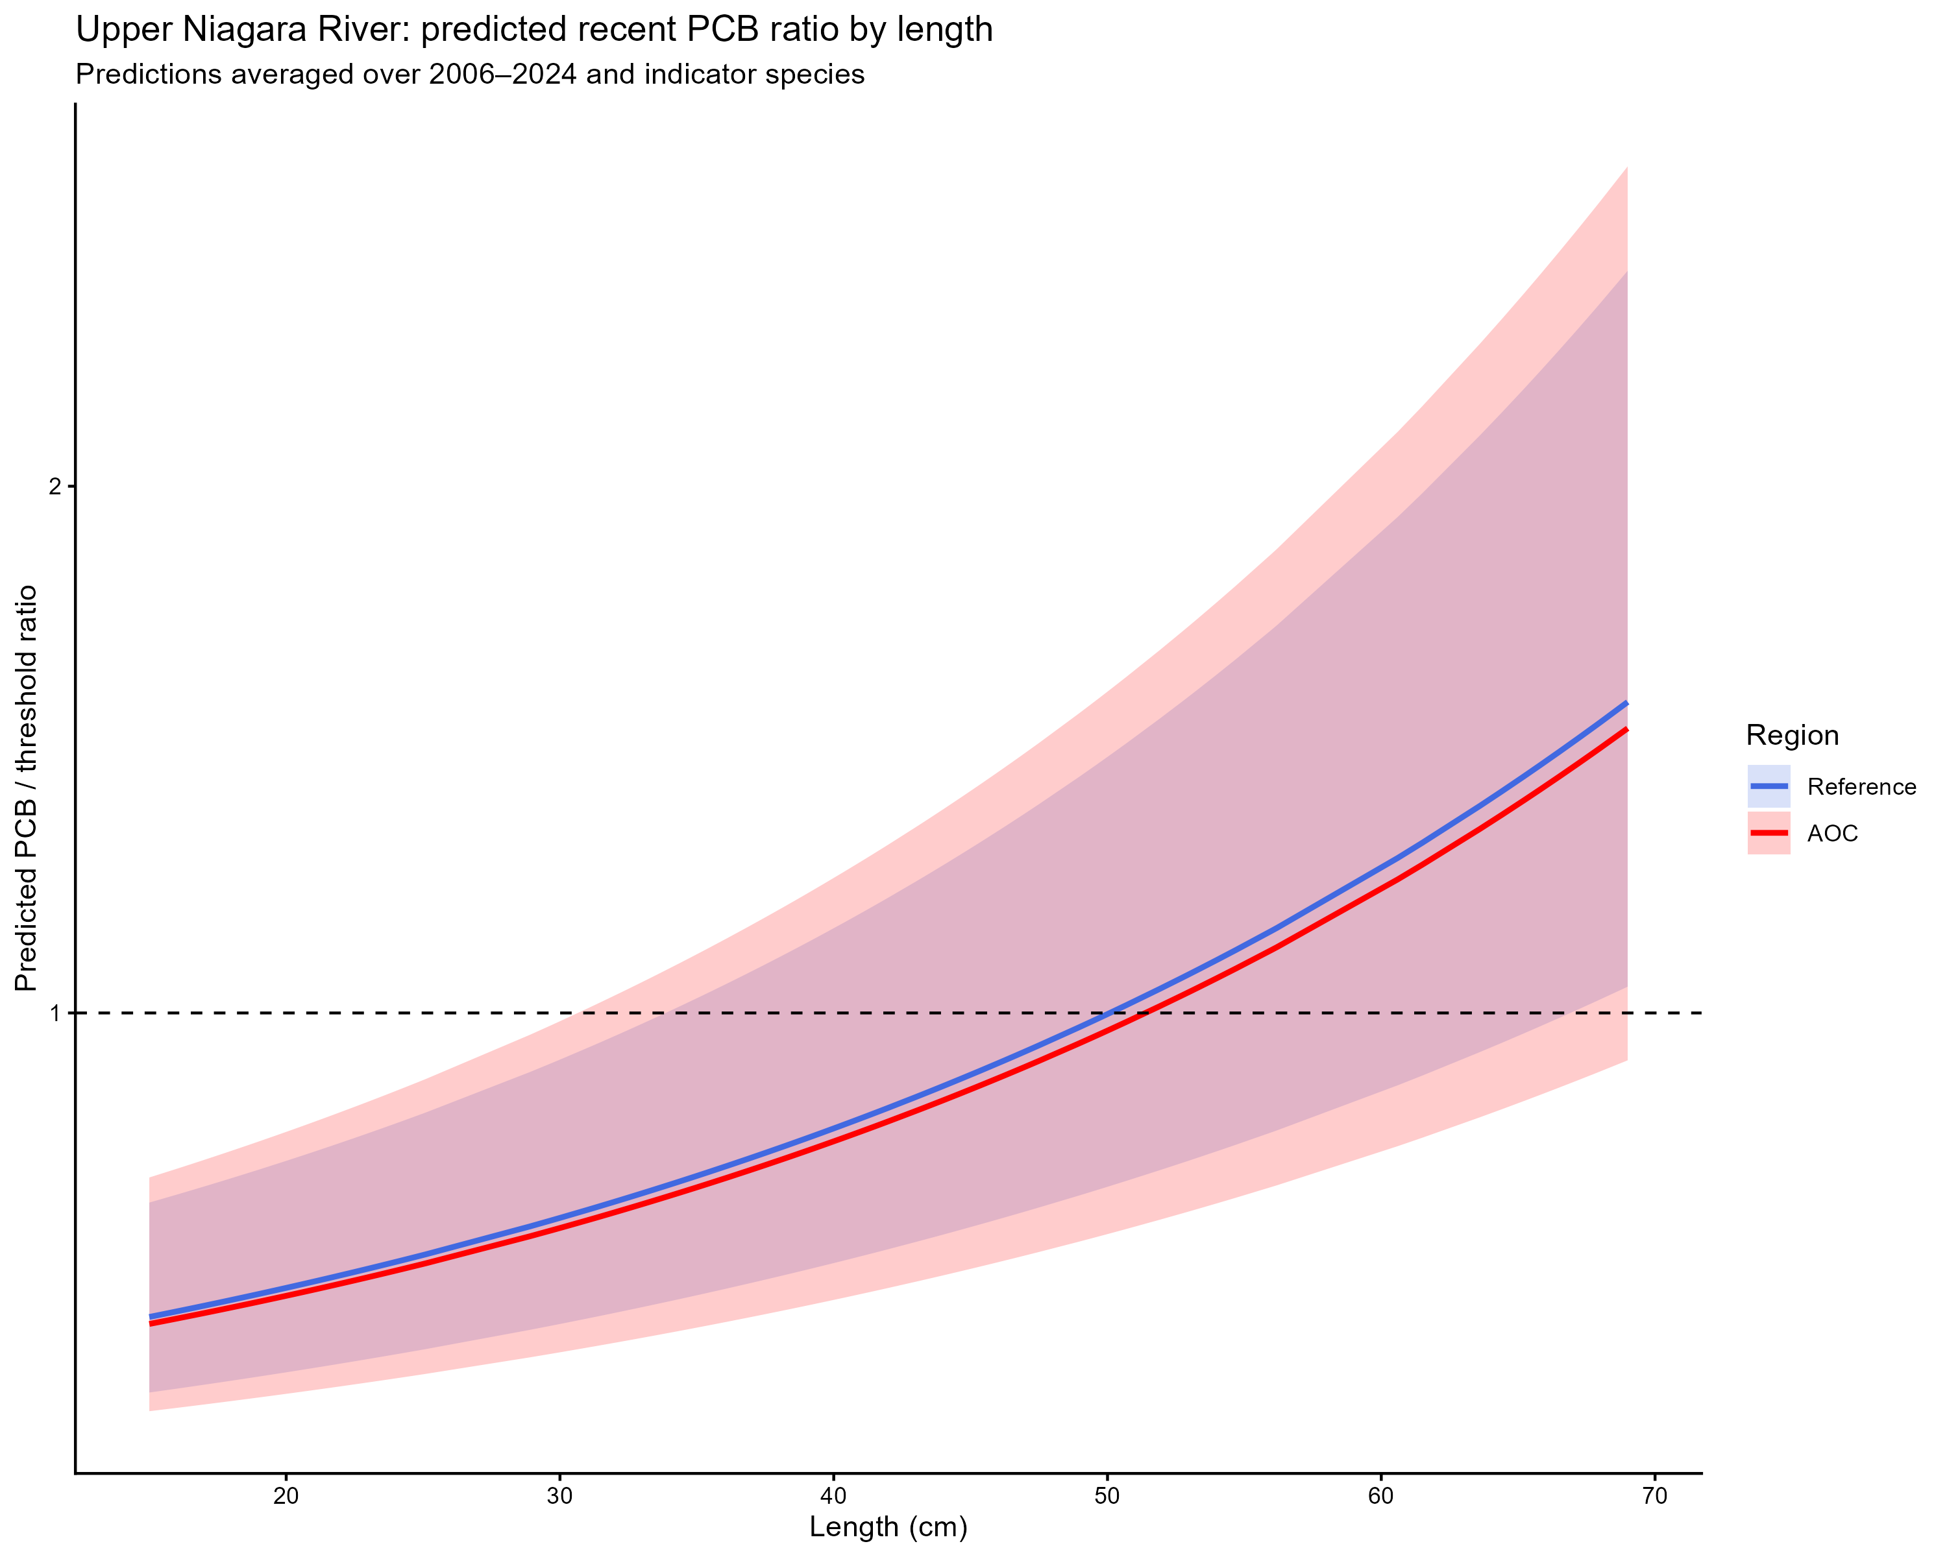
Figure 7.3: Predicted PCB concentrations relative to the consumption threshold (105 ng/g) as a function of fish length in the Upper Niagara River and Lake Erie reference sites. Predictions are based on generalized additive models and represent recent conditions (2006–2024), averaged across indicator species and excluding site-level random effects. Shaded ribbons represent approximate 95% confidence intervals. The dashed horizontal line indicates the 8 meal/month consumption threshold (PCB/threshold ratio = 1).
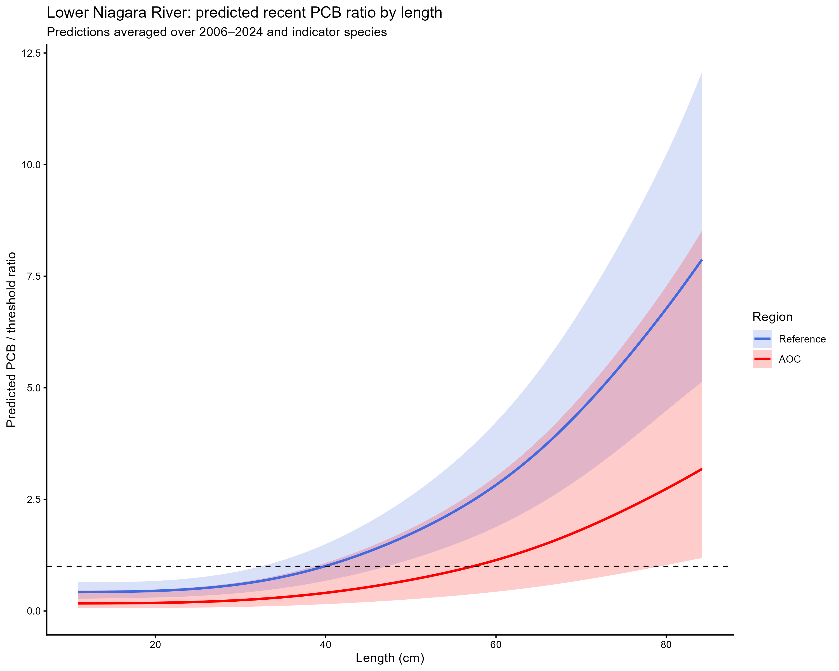
Figure 7.4: Predicted PCB concentrations relative to the consumption threshold (105 ng/g) as a function of fish length in the Lower Niagara River and Lake Ontario reference sites. Predictions are based on generalized additive models and represent recent conditions (2006–2024), averaged across indicator species and excluding site-level random effects. Shaded ribbons represent approximate 95% confidence intervals. The dashed horizontal line indicates the 8 meal/month consumption threshold (PCB/threshold ratio = 1).
Model results indicated that PCB concentrations increased significantly with fish length across species in both the Upper and Lower Niagara River, consistent with bioaccumulation (p < 0.001 in both models; Figures 7.3 and 7.4; Gewurtz, Bhavsar, and Fletcher (2011); Bhavsar et al. (2011)). Temporal smooths were also highly significant (p < 0.001), reflecting long-term declines followed by stabilization in recent years. Species effects were significant in both reaches, indicating substantial differences in PCB accumulation among taxa. Site-level variability was also important in the Upper Niagara River (p < 0.001), while in the Lower Niagara River, spatial variation was better captured by the two-dimensional smooth of latitude and longitude (p < 0.001), with little residual site-level variation.
In the Upper Niagara River model, the effect of region (AOC vs. Lake Erie reference) was positive but not statistically significant (estimate = 0.12 ± 0.32 SE, p = 0.69), indicating no clear difference between AOC and reference sites after accounting for fish length, species, and temporal effects. In the Lower Niagara River, the regional effect was negative (estimate = -0.94 ± 0.61 SE), indicating lower PCB concentrations in the AOC relative to Lake Ontario reference sites, although this difference was also not statistically significant (p = 0.12).
Model predictions indicated that PCB concentrations increased with fish length across species in both reaches, with larger fish more likely to exceed the advisory threshold. In the Upper Niagara River, predicted PCB concentrations in the AOC were slightly higher than those in Lake Erie reference sites; however, this difference was small and not statistically significant (mean ratio = 1.13, 95% CI: 0.61–2.10, p = 0.69), with substantial overlap in uncertainty across the full range of fish sizes. In the Lower Niagara River, predicted PCB concentrations were consistently lower in the AOC than in Lake Ontario reference sites (mean ratio = 0.39, 95% CI: 0.12–1.29, p = 0.12), although this difference was also not statistically significant.
Model predictions for recent years (2006–2024), averaged across indicator species, showed that in the Upper Niagara River, predicted PCB concentrations increased with fish length and crossed the advisory threshold at intermediate sizes (~40–50 cm, Figure 7.3). Predicted values for the AOC were consistently slightly higher than reference sites, but differences were small and uncertainty overlapped across all sizes (Figure 7.3).
Despite high rates of exceedance in larger fish, these patterns were similar between AOC and reference regions and were strongly driven by fish size. This is consistent with observed patterns of bioaccumulation of PCBs in fish in the Great Lakes ecosystem (Bhavsar et al. 2011; Gewurtz, Bhavsar, and Fletcher 2011; Ion et al. 1997). The absence of a statistically significant regional effect in the Upper Reach, combined with the consistent tendency toward lower concentrations in the AOC in the Lower Reach, indicates that PCB concentrations in Niagara River fish are not elevated relative to appropriate reference systems when controlling for key biological and spatial factors. Overall, these results support the conclusion that fish consumption restrictions in the Niagara River AOC are not driven by locally controllable PCB sources, but instead reflect broader regional contamination patterns within Lakes Erie and Ontario.
The observed association between PCB concentrations and size likely reflects the results from Tier 3A. Larger fish, particularly trout and salmonids, tend to be highly mobile or migratory and integrate contaminants from broad-basin scale environments (Scott and Crossman 1973; Nettles et al. 1987; Haynes et al. 1986; Alderstein et al. 2009). As these species grow and age, they bioaccumulate PCBs, resulting in higher concentrations and greater likelihood of exceeding advisory thresholds. In contrast, smaller and more resident species such as white perch, rock bass, and freshwater drum occupy more localized habitats and therefore provide a stronger indication of local contaminant conditions (Scott and Crossman 1973; Gewurtz, Bhavsar, and Fletcher 2011). The absence of consistently elevated PCB concentrations among smaller size classes in the AOC suggests that these more resident taxa are not strongly influenced by localized PCB sources relative to reference sites.
The apparent discrepancy between the high proportion of fish exceeding the threshold in raw observations and lower model-predicted values reflects differences in interpretation. Raw exceedance rates are influenced by the distribution of sampled fish sizes, particularly the inclusion of larger individuals, whereas the GAM predictions represent adjusted expectations for a typical fish after accounting for biological and spatial factors. Together, these analyses provide complementary lines of evidence supporting the conclusion that PCB contamination patterns are primarily structured by size, species, and regional context rather than localized AOC effects.
Overall, evidence from Tier 3B does not provide strong support for the conclusion that fish consumption restrictions in the Niagara River AOC are driven by locally controllable sources of PCBs.

Tier 3C: Temporal Projections of PCBs in the Niagara River AOC
Temporal trends in PCB concentrations were assessed separately for the Upper and Lower Niagara River using generalized additive models (GAMs) applied to AOC-only data. PCB concentrations (ng/g) were log-transformed to meet model assumptions. Models included a parametric linear term for year to estimate long-term temporal trends, a smooth term for fish length to account for size-dependent bioaccumulation, species as a fixed effect, and site as a random effect.
The parametric year coefficient was used to estimate the rate of change in PCB concentrations over time. This rate was converted to a decay constant (k) and corresponding half-life (time required for concentrations to decline by 50%). Projections assume a constant log-linear rate of decline derived from the observed temporal trend.
To evaluate future conditions, model predictions were generated at representative fish lengths (lower quartile, median, and upper quartile of observed lengths). Predictions were anchored to the most recent year of data and extrapolated forward assuming a constant rate of decline. The time required for predicted PCB concentrations to fall below the unrestricted consumption threshold of 105 ng/g was calculated for each representative length. Uncertainty was propagated using standard errors from both the model predictions and the temporal slope to generate 95% confidence intervals. An estimated timeline of 10 years or more is considered unsupportive of redesignating this BUI.
Table 7.1 Estimated time to unrestrictive PCB threshold for median, upper-quartile, and lower-quartile-sized fish in the AOC, using GAM-derived half-life decay model. Projected PCBs concentration in median, upper-quartile, and lower-quartile-length fish in the Niagara River AOC. Predicted concentration is based on GAMM-derived half-life decay model. Thresholds represent an “unrestrictive” advisory of 8 meals per month, based on MECP advisory thresholds.
Niagara River Reach | Representative group | Length (cm) | Predicted PCB (current year) | Threshold (ng/g) | Years to 105 ng/g | 95% CI | Outcome
Upper | Lower quartile | 30 | 29.4 | 105 | 0.0 | -15.6–15.6 | Supportive
 | Median | 45 | 45.8 | 105 | 0.0 | -14.3–14.3 | Supportive
 | Upper quartile | 55 | 63.1 | 105 | 0.0 | -14.2–14.2 | Supportive
Lower | Lower quartile | 30 | 76.5 | 105 | 0.0 | -4.3–4.3 | Supportive
 | Median | 50 | 189.5 | 105 | 11.7 | 7.5–15.8 | Unsupportive
 | Upper quartile | 65 | 373.4 | 105 | 25.1 | 20.8–29.3 | Unsupportive
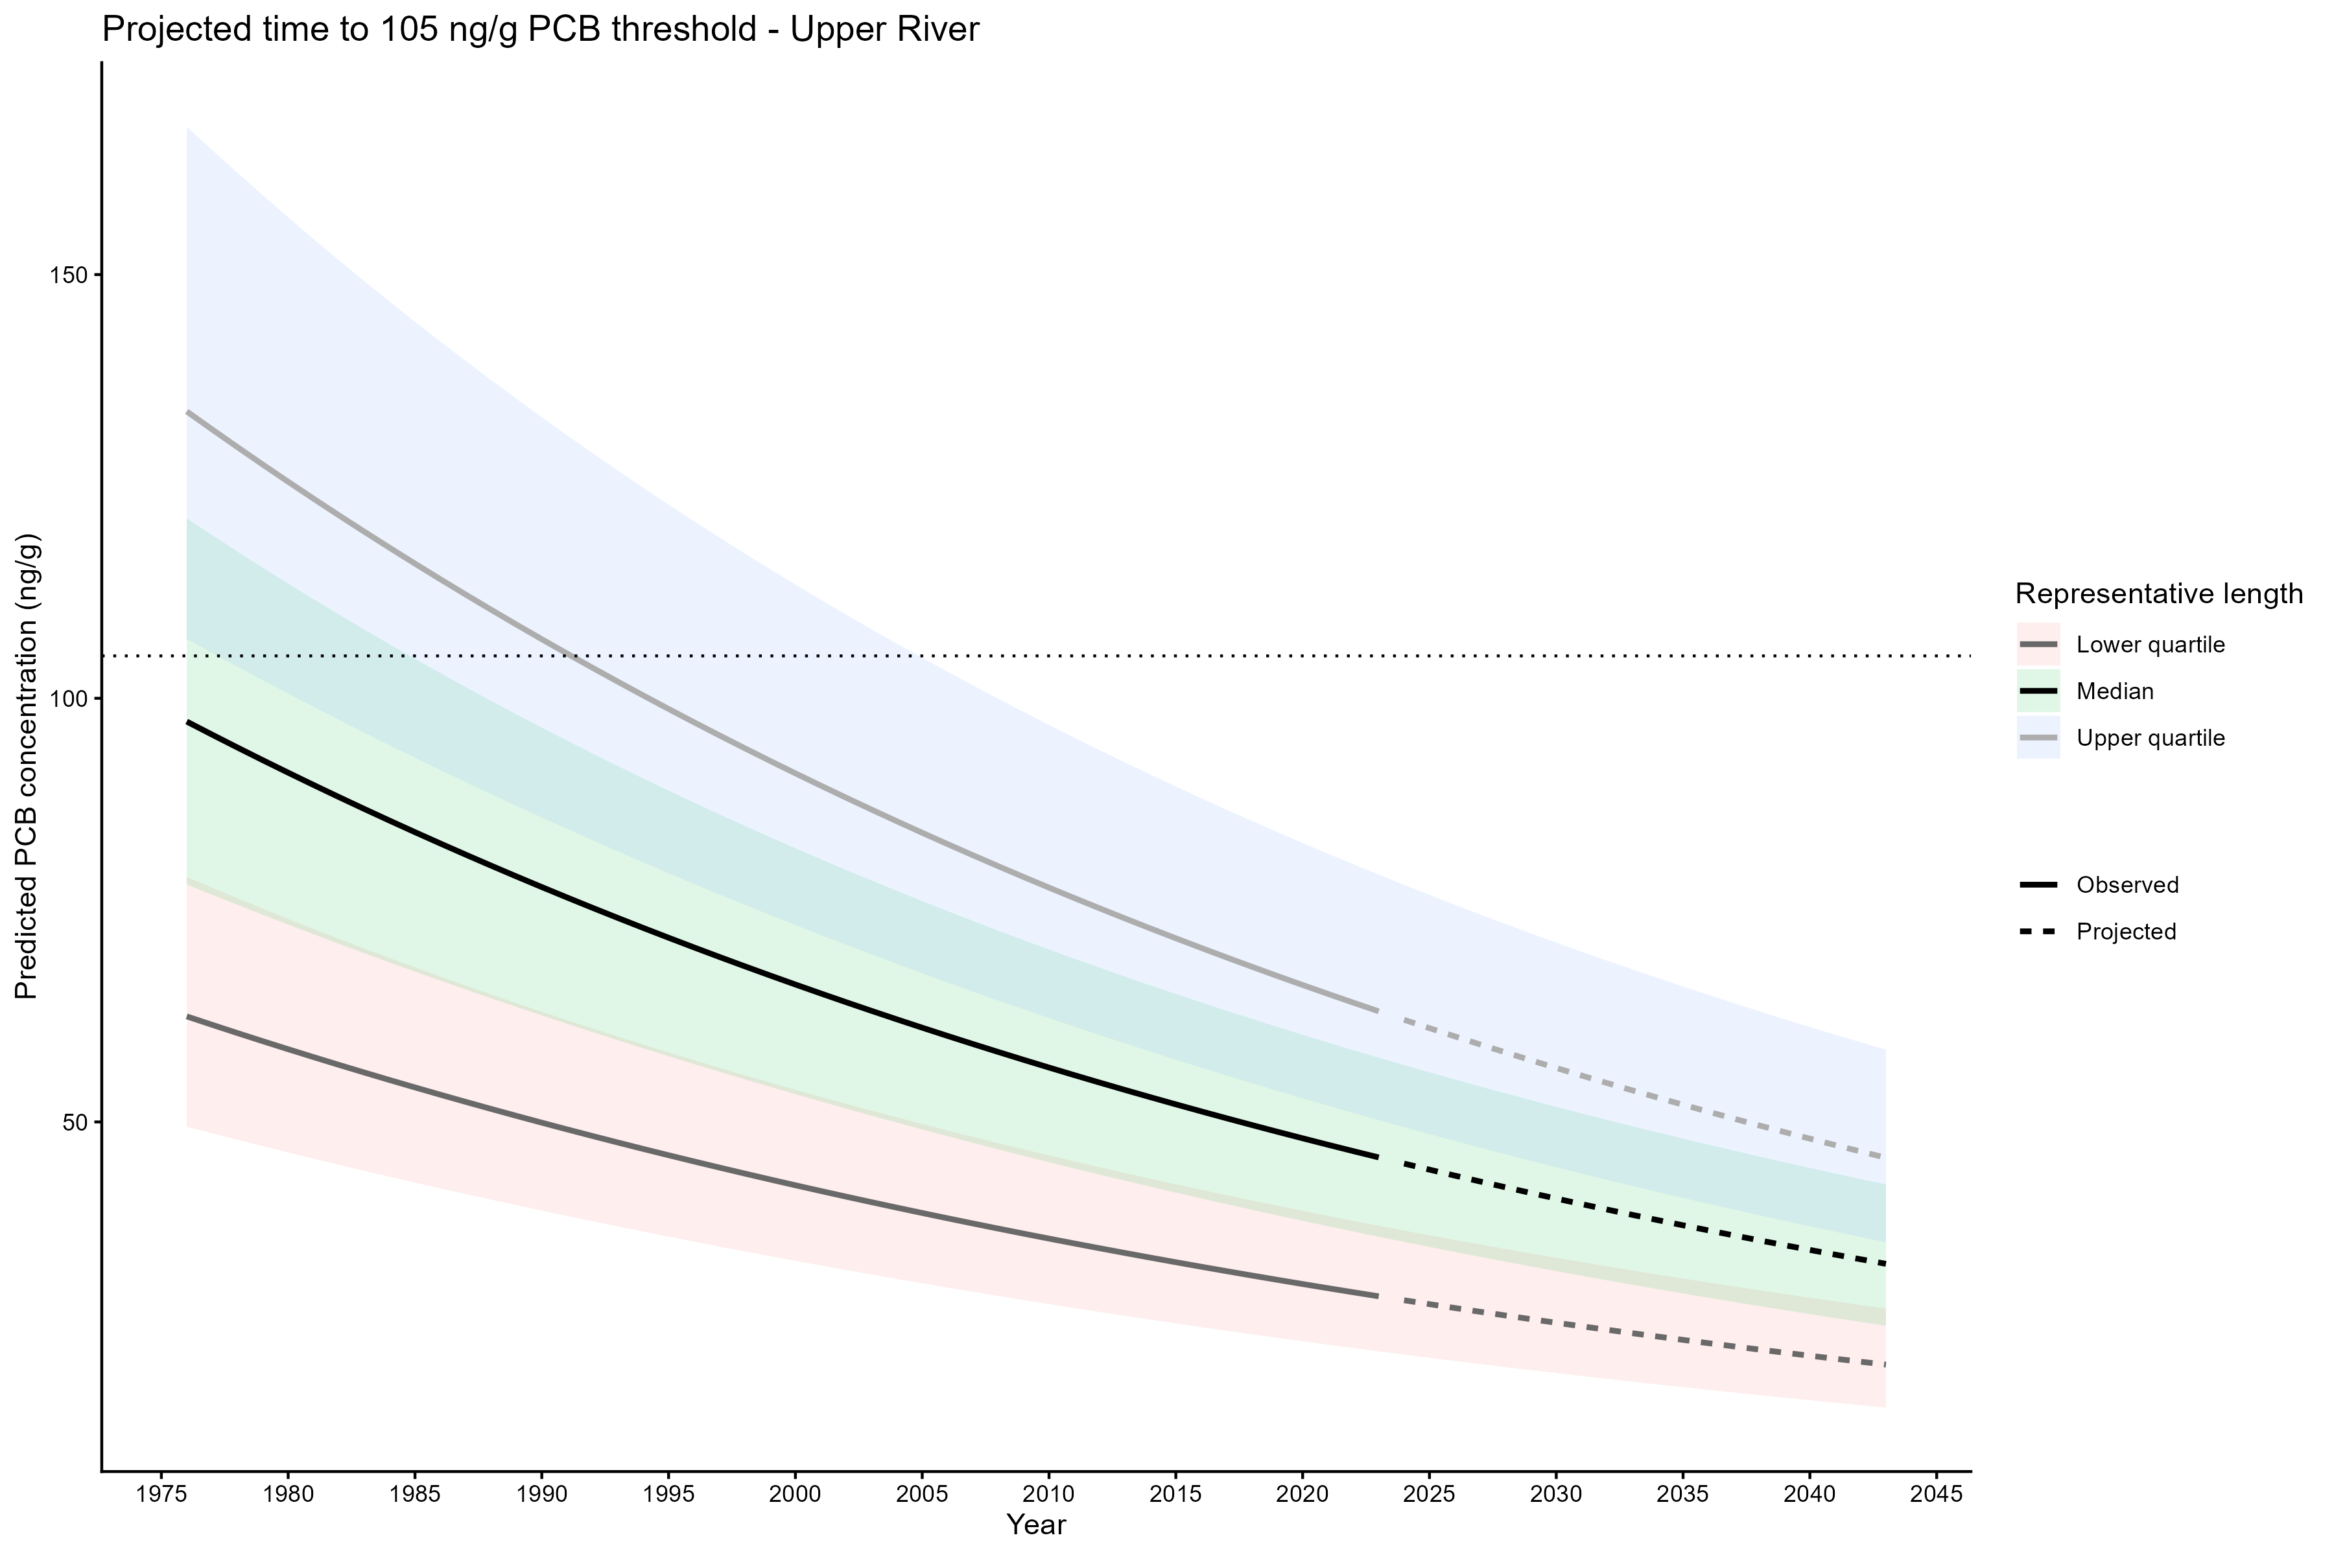
Figure 7.5: Projected PCBs concentration in median, upper-quartile, and lower-quartile-length fish in the Upper Reach of the Niagara River AOC. Predicted concentration is based on GAMM-derived half-life decay model. Solid lines represent predicted values within the temporal range of observations, dashed lines represent projected future concentrations, ribbons show 95% CI, and horizontal dotted lines represent the PCB threshold corresponding to a consumption advisory of 8 meals per month (105 ng/g).
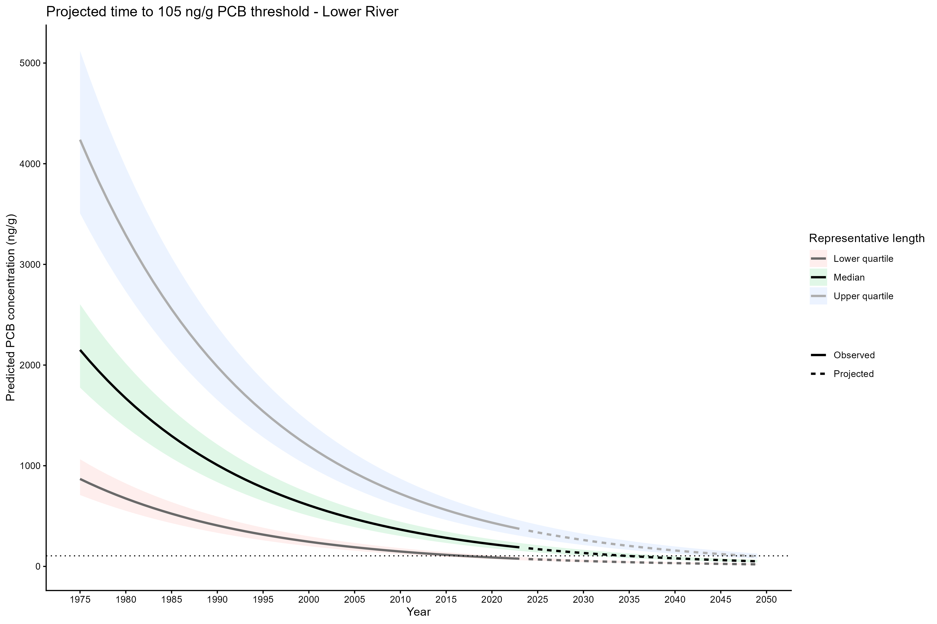
Figure 7.6: Projected PCBs concentration in median, upper-quartile, and lower-quartile-length fish in the Lower Reach of the Niagara River AOC. Predicted concentration is based on GAMM-derived half-life decay model. Solid lines represent predicted values within the temporal range of observations, dashed lines represent projected future concentrations, ribbons show 95% CI, and horizontal dotted lines represent the PCB threshold corresponding to a consumption advisory of 8 meals per month (105 ng/g).
PCB concentrations in the Upper Niagara River appear to have declined to levels consistent with unrestricted consumption across all representative fish sizes. The consistency of results across size classes and the negative (pre-threshold) confidence intervals suggest that recovery has already occurred and is robust to model uncertainty. These results provide strong support that PCB contamination is no longer a limiting factor for fish consumption in the Upper River.
In contrast, PCB concentrations in the Lower Niagara River remain size-dependent and elevated in larger fish. While smaller individuals are already below the threshold, median and larger fish are expected to require approximately one to three decades to reach unrestricted levels. This indicates that although recovery is underway, it is incomplete and strongly influenced by bioaccumulation processes (Bhavsar et al. 2011; Gewurtz, Bhavsar, and Fletcher 2011). The persistence of elevated concentrations in larger fish suggests continued legacy contamination or slower recovery dynamics in the Lower River relative to the Upper River (Pelletier and Lepage 2003).
Together, the results of Tier 3C indicate spatial heterogeneity in recovery within the AOC. The Upper River shows evidence of completed recovery with respect to PCB contamination, whereas the Lower River continues to exhibit delayed recovery, particularly for larger, more bioaccumulative fish. However, given the results of Tiers 3A and 3B that demonstrated spatial similarities in PCB contamination in the Lower Niagara River and Lake Ontario reference sites, it is not likely that additional remedial actions in the AOC will meaningfully contribute to increased rates of decline of PCBs in AOC fish.

Tier 3 Overall
Overall, Tier 3 lines of evidence collectively indicate that PCB-related impairment in the Niagara River AOC is largely governed by fish size, species ecology, and spatial context, rather than a consistent AOC-wide effect. Tier 3A (recent concentrations and advisory exceedances) and Tier 3B (model-based comparisons to reference conditions) both showed that smaller-bodied and less bioaccumulative species generally align with or approach reference expectations, while larger, more mobile species continue to exhibit elevated PCB concentrations consistent with broader basin-scale exposure and bioaccumulation. Temporal analysis in Tier 3C further supports this pattern, demonstrating clear declines in PCB concentrations through time, with the Upper River now predicted to be below unrestricted consumption thresholds across representative fish sizes, indicating effective recovery. In contrast, the Lower River shows continued improvement but with delayed recovery in larger fish, where projected timelines to reach unrestricted thresholds extend one to three decades. Together, these findings suggest that PCB contamination in the Niagara River AOC is not uniformly elevated relative to reference conditions, but remains size- and location-dependent, with residual impairment primarily associated with larger-bodied fish in the Lower River. The results of Tier 3 are summarized in Table 8.2.
Table 8.2. Decision support matrix for Tier 3 evidence lines.
 | Main Findings | Decision
Tier 3A Comparison of PCB Threshold Exceedances in the AOC Fish vs Reference | Most species in the AOC do not have greater rates of PCB threshold exceedance for 8 meal/month advisories. Those that do exceed reference are mostly larger fish that are not likely highly resident to the AOC. | Supports passing Tier 3
Tier 3B Modeled PCB Concentrations in AOC Fish vs Reference | Modeled PCB concentrations in the AOC are not significantly different from those in reference areas. High concentrations of PCBs in fish (both in the AOC and reference) are associated with larger, non-resident fish. | Supports passing of Tier 3
Tier 3C Temporal Projections of PCBs in the Niagara River AOC | Temporal trends support declining PCB concentrations in AOC fish. In the Upper Reach, modeled PCB concentrations are already below the restrictive threshold in median, lower-quartile, and upper-quartile length fish. However, in the Lower Reach, PCB concentrations in median and upper-quartile length fish are not expected to reach an unrestrictive benchmark in the following decade. | Partial support with continued monitoring in PCB concentrations in the Lower Niagara River as concentrations continue to drive consumption restrictions in median and larger fish.
Overall Weight of Evidence Tier 3: | Supports Redesignating but continued monitoring of PCB contaminants in the AOC, especially the Upper Reach, is recommended.

RECOMMENDATION
Based on the evaluation of Tiers 1-3, evidence suggests that, while fish consumption advisories remain largely restrictive in the Niagara River AOC, the drivers of these advisories are not likely caused by locally controllable sources of priority contaminants. Thus, it is recommended to redesignate this BUI as “Not Impaired”.
Although data analyzed in this report provide overall support for delisting BUI #1, it is recommended that additional monitoring be performed in order to continue to track improvements in PCB contamination of the AOC over time.
Data availability remains a key limitation in interpreting these results, as contaminant monitoring within the Niagara River AOC (particularly in the Upper Reach) is sparse for most species and especially limited in recent years (2006 onward). As a result, analyses were conducted using aggregated, multi-species models rather than species-specific assessments, which may obscure important differences among taxa. Furthermore, from a management perspective, it is likely that sparse recent data has contributed to outdated fish consumption advisories in the AOC that may not reflect the current contaminant burden in AOC fish. It is recommended that additional fish telemetry studies be conducted on larger, more contaminated fish such as trout and salmonids to better understand fish associations with AOC sources of contaminants. These data gaps introduce additional uncertainty in both trend estimation and future projections, and highlight the need for more consistent, species-resolved fish contaminant monitoring within the AOC to improve the robustness of future assessments and better track recovery over time.
Furthermore, fish consumption surveys indicated that walleye, catfish, yellow perch, and other species such as lake whitefish and lake sturgeon may be consumed in higher frequencies among the top 5% of fish consumers in the AOC, possibly including subsistence fishers. Additional information about which species, size classes, and locations of fish consumed in large quantities in the AOC would be useful to ascertain how often these species are actually and/or desired to be consumed on a monthly basis. Additionally, species such as lake whitefish, lake sturgeon, and black crappie do not have consumption advisories in the AOC despite being indicated as potential species of interest through community survey. These species should be targeted in future fish contaminant monitoring to provide accurate consumption advice in the AOC. While species like lake sturgeon and American eel are prohibited to catch by the general public, Indigenous groups hold rights to manage, protect, and harvest these species. Including consumption advice for these species would therefore help these populations, particularly subsistence fishers, to manage health risks associated with fish consumption.

REFERENCES
Alderstein, Sara, Edward Rutherford, David Clapp, Randy Claramunt, and James Johnson. 2009. “Seasonal Migration of Salmonids in the Great Lakes Interpreted from Coded-Wire-Tag Recoveries.” International Council for the Integration of Individual Based Information into Fishery and Environmental Management Applications ICES CM 2009 (J:13). https://www.ices.dk/sites/pub/CM%20Doccuments/CM-2009/J/J1309.pdf.
Bhavsar, Satyendra P., Emily Awad, Chris G. Mahon, and Steve Petro. 2011. “Great Lakes Fish Consumption Advisories: Is Mercury a Concern?” Ecotoxicology (London, England) 20 (7): 1588–98. https://doi.org/10.1007/s10646-011-0731-0.
Gewurtz, Sarah B., Satyendra P. Bhavsar, and Rachael Fletcher. 2011. “Influence of Fish Size and Sex on Mercury/PCB Concentration: Importance for Fish Consumption Advisories.” Environment International 37 (2): 425–34. https://doi.org/10.1016/j.envint.2010.11.005.
Haynes, James M., David C. Nettles, Kevin M. Parnell, Michael P. Voiland, Robert A. Olson, and Jimmy D. Winter. 1986. “Movements of Rainbow Steelhead Trout (Salmo Gairdneri) in Lake Ontario and a Hypothesis for the Influence of Spring Thermal Structure.” Journal of Great Lakes Research 12 (4): 304–13. https://doi.org/10.1016/S0380-1330(86)71730-9.
Ion, J, Y De Lafontaine, P Dumont, and L Lapierre. 1997. “Contaminant Levels in St. Lawrence River Yellow Perch (Perca Flavescens): Spatial Variation and Implications for Monitoring.”
Nettles, David C., James M. Haynes, Robert A. Olson, and Jimmy D. Winter. 1987. “Seasonal Movements and Habitats of Brown Trout (Salmo Trutta) in Southcentral Lake Ontario.” Journal of Great Lakes Research 13 (2): 168–77. https://doi.org/10.1016/S0380-1330(87)71640-2.
Pelletier, Magella, and Serge Lepage. 2003. “Spatial and Temporal Evolution of the Geochemistry and Sedimentary Processes of Lake SaintFrançois in the 20th Century.” https://publications.gc.ca/collections/collection_2014/ec/En152-1-225-2003-1-eng.pdf.
Scott, W. B., and E. J. Crossman. 1973. Freshwater Fishes of Canada. Bulletin 184. https://publications.gc.ca/collections/collection_2019/mpo-dfo/Fs94-184-eng.pdf

APPENDIX 1: ACTIONS – COMPLETED AND FUTURE

Actions completed 2019-2025
# | Recommended Action | 2019-2025 | Lead(s)
Data Collection
 | Administer the online fish consumption survey of Niagara River anglers to determine fish of interest. | ☑ Completed | NRRAP
 | Conduct in-person surveys of anglers at various locations along the Canadian side of the Niagara River to determine fish of interest. | ☑ Completed | NRRAP
 | Engage with local Indigenous communities to gather information about their Niagara River fish consumption. | ☑ Completed | ECCC, MECP, NRRAP
 | Translate fish consumption survey into other relevant languages (e.g., Arabic, French, Spanish, Mandarin, Vietnamese) and administer to non-English speaking anglers, where possible. | ☑ Completed | NRRAP
 | Collect fish samples from the Niagara River to measure contaminants in fish tissues as part of the Ontario Fish Contaminants Monitoring Program. | ☑ Completed | MECP
 | Gather information from ongoing water quality monitoring programs (e.g., Upstream-Downstream, mussel biomonitoring) to support the multiple lines of evidence required to assess the delisting criteria (i.e., contaminants related to fish consumption advisories). | ☑ Completed | NRRAP, ECCC, CWA MECP
 | Gather information from ongoing sediment monitoring programs (e.g., NRTMP, Upstream-Downstream, Niagara Bar location) to support the multiple lines of evidence required to assess the delisting criteria (i.e., contaminants related to fish consumption advisories). | ☑ Completed | MECP, ECCC, CWA
Outreach and Education
 | Develop and distribute ‘Eat Safe Fish’ educational materials (based on the Guide to Eating Ontario Fish) to share information about Niagara River fish consumption*. | ☑ Completed | NRRAP
 | Create and maintain and update a webpage on the Niagara River RAP website to share information about eating safe fish from the Niagara River. | ☑ Completed* | NRRAP
 | Translate outreach materials into other relevant languages to reach non-English speaking fishers. | ☑ Completed | NRRAP
 | Continue to produce and make available the Guide to Eating Ontario Fish. | ☑ Completed | MECP

Outstanding Actions 2026 - onward
# | Recommended Action | 2025 | 2026 | 2027 | 2028 | 2029 | Lead(s)
1.1 | Collect fish samples from the Niagara River to measure contaminants in fish tissues as part of the Ontario Fish Contaminants Monitoring Program. |  | ● | ● |  |  | MNR/MECP
1.2 | Gather information from ongoing water quality monitoring programs (e.g., Upstream-Downstream monitoring) to support the multiple lines of evidence required to assess the delisting criteria (i.e., contaminants related to fish consumption advisories). |  | ● | ● |  |  | ECCC, CWA, MECP
1.3 | Gather information from ongoing sediment monitoring programs (e.g., NRTMP, Upstream-Downstream, Niagara Bar location) to support the multiple lines of evidence required to assess the delisting criteria (i.e., contaminants related to fish consumption advisories). |  | ● | ● |  |  | MECP, ECCC, CWA
1.4 | Update and distribute ‘Eat Safe Fish’ educational materials (based on the Guide to Eating Ontario Fish) to share information about Niagara River fish consumption. |  | ● | ● |  |  | NPCA
1.5 | Update the 'Eat Safe Fish' webpage on the Niagara River RAP website to share information about eating safe fish from the Niagara River. |  | ● | ● |  |  | NPCA
1.6 | Design and install signage at key Niagara River fishing locations to inform anglers where to find information about fish consumption. |  |  | ● |  |  | NPCA/Niagara Parks
1.7 | Compile all Niagara River fish consumption survey results and complete a tiered assessment using the framework outlined in Delisting Strategy (2021). | ● | ● | ● |  |  | NPCA/MECP
 | Tiers 1-2: identify suitable reference sites for assessment. |  | ● |  |  |  | MECP, CWA, NRRAP
 | Tier 3: determine “multiple lines of evidence” and “all feasible remedial actions” (if Tiers 1-2 fail). |  | ● | TBD |  |  | MECP, CWA, NRRAP
1.8 | Based on findings in 1.7, assess the BUI delisting criteria and prepare a report to highlight the key findings and recommendation for endorsement by the NRRAP. |  | ● | ● |  |  | NPCA
 | If BUI status recommendation is 'Not Impaired', proceed with re-designation process (Appendix X) |  |  | TBD |  |  | NRRAP Council
 | If BUI status recommendation is 'Impaired', further discussions will be required for next steps. |  |  | TBD

APPENDIX 2: TIERED ASSESSMENT FRAMEWORK

APPENDIX 3: LIST OUTREACH AND ENGAGEMENT SUMMARY AND RESULTS

https://www.ontario.ca/page/guide-eating-ontario-fish
UNRESTRICTED is defined as being able to eat 8 or more meals per month of the desired fish, PARTIALLY RESTRICTED means that a consumer should use caution and limit consumption of the desired fish per month (ranging from 1, 2 or 4 meals/month), while RESTRICTED consumption occurs when a consumer is advised not to eat any meals of a particular size of the fish.
http://ourniagarariver.ca/wp-content/uploads/2021/05/Niagara-River-Area-of-Concern-Delisting-Strategy-FINAL-May-2021.pdf

